THE EPISCOPAL DIOCESE OF
SOUTH DAKOTA

2013

JOURNAL
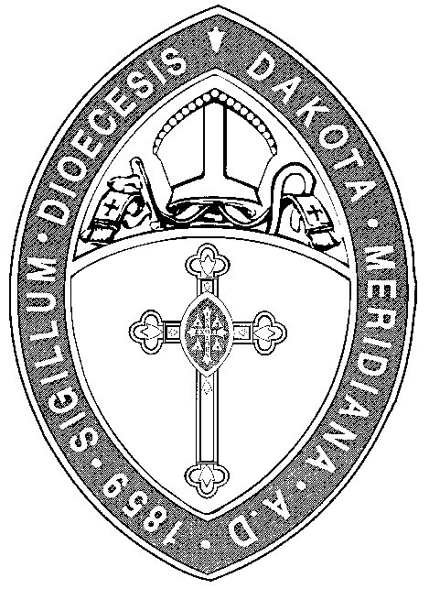

of the

ONE HUNDRED TWENTY-NINTH
ANNUAL CONVENTION

held at

PIERRE, SOUTH DAKOTA

September 27-28, 2013

together with the Constitution, Canons,
And Rules of Order

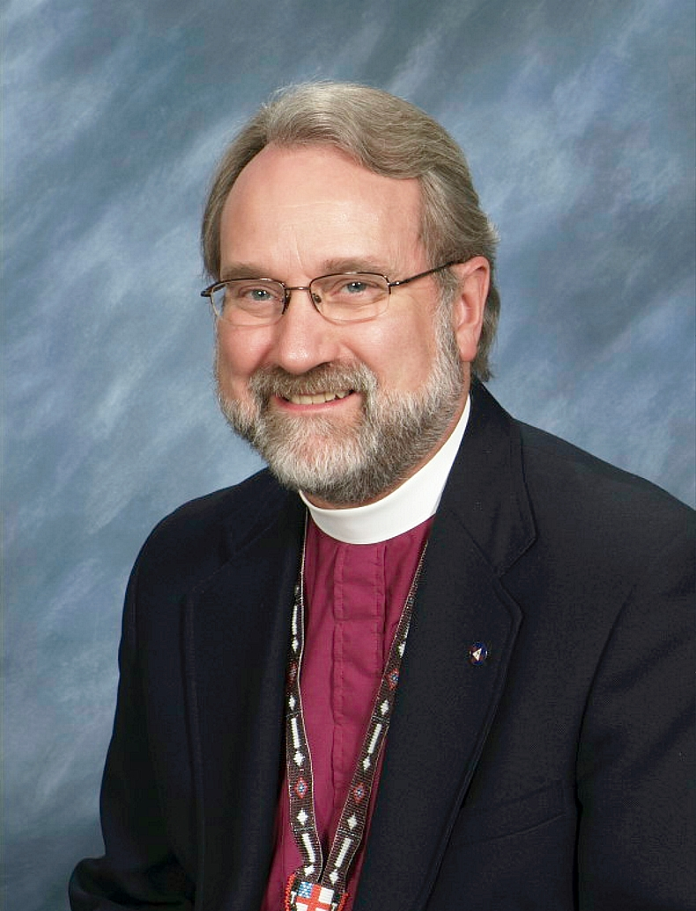

The Right Reverend
John T. Tarrant
X Bishop of South Dakota

Mission Statement
of the Diocese of South Dakota

The Mission of the Diocese of South Dakota is to restore all people to unity with God and each other in Christ through the ministry of all.

VISION OF THE EPISCOPAL CHURCH
IN SOUTH DAKOTA

The Episcopal Church in South Dakota is a sacred circle gathered around Jesus in prayer, loving and serving God and our neighbor in Jesus’ name.

CONTENTS

Diocesan Mission Statement 2
Diocesan Bishops 4
Directory
Deanery Map 6
List of Churches in Deaneries 6
Directory of Churches and Officers 8
The 2013 Convention
2013 Clergy Roll 14
2013 Lay Delegates 16
Official Acts of the Bishop 18
Minutes of Convention 19
Bishop’s Address 24
Annual & Special Convocations of the Missionary District of South Dakota 27
Annual & Special Conventions of the Diocese of South Dakota 28
The Niobrara Convocation
Niobrara Convocation Host Sites 30
Executive Committees—Membership & Reports
Diocese of South Dakota Officers 34
Diocesan Council Annual Report 35
Commissions/Committees—Membership & Reports
Membership 38
Annual Reports
Canon to the Ordinary 39
Centennial Challenge Fund 39
Commission on Ministry 40
Ecumenical Relations 41
Episcopal Women’s Scholarships 41
Historiographer 42
Youth & Camp 42
Stewardship Commission 43
United Thank Offering 43
Financial Reports
Statement of Income & Expenditures 48
Grant Report 49
Pledges to the Diocese of South Dakota 50
Statistical Reports 51
Parochial Financial Summary
Parochial Vital Statistics Summary

Diocesan Bishops

The First Bishop
The Right Reverend William Hobart Hare, 1883-1909

The Second Bishop
The Right Reverend Frederick Foote Johnson, 1910-1911

The Third Bishop
The Right Reverend George Biller, Jr., 1912-1915

The Fourth Bishop
The Right Reverend Hugh Latimer Burleson, 1916-1931

The Fifth Bishop
The Right Reverend W. Blair Roberts, 1931-1954

The Sixth Bishop
The Right Reverend Conrad H. Gesner, 1954-1970

The Seventh Bishop
The Right Reverend Walter Heath Jones, 1970-1983

The Eighth Bishop
The Right Reverend Craig Barry Anderson, 1984-1992

The Ninth Bishop
The Right Reverend Creighton Leland Robertson, 1994-2009

The Tenth Bishop
The Right Reverend John Thomas Tarrant, 2010-

Bishops Suffragan
The Right Reverend William P. Remington, 1918-1922
The Right Reverend W. Blair Roberts, 1922-1931
The Right Reverend Harold S. Jones, 1971-1976

Bishops Coadjutor
The Right Reverend Conrad H. Gesner, 1945-1954
The Right Reverend Lyman C. Ogilby, 1964-1970
The Right Reverend John T. Tarrant, 2009

Bishops Assistant
The Right Reverend Frederick Foote Johnson, 1905-1909



DIRECTORY

Deaneries + Churches + Vestries

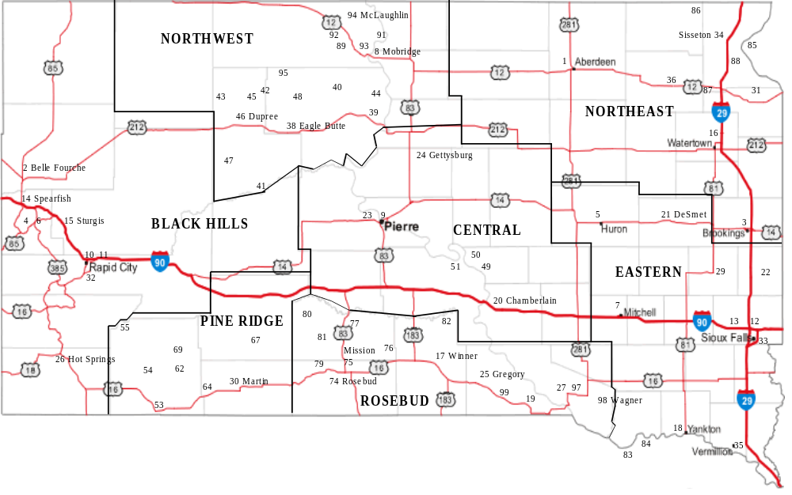
Deaneries

Black Hills Deanery
The Reverend Bunker Hill, Dean

Belle Fourche, St. James | Rapid City, Emmanuel
Deadwood, St. John’s | Rapid City, St. Andrew’s
Hot Springs, St. Luke’s | Rapid city, St. Matthew’s
Lead, Christ Church | Spearfish, Church of All Angels
Red Shirt Table, Christ Church | Sturgis, St. Thomas

Central Deanery

The Reverend Mercy Hobbs, Dean

Chamberlain, Christ Church | Gettysburg, Christ Church
Crow Creek, St. John the Baptist | Lower Brule, Holy Comforter & St. Albans
Ft. Pierre, St. Peter’s | Iron Nation, Messiah & Ft. Hale, Holy Name
Ft. Thompson, Christ Church | Pierre, Trinity

Eastern Deanery
The Rev. Christina O’Hara, Dean

DeSmet, St. Stephen’s | Santee, NE, Our Most Merciful Savior
Flandreau, St. Mary’s & Our Blessed Redeemer | Sioux Falls, Calvary Cathedral
Howe Creek, NE, Blessed Redeemer | Sioux Falls, Good Shepherd
Huron, Grace | Sioux Falls, Holy Apostles
Madison, Grace | Vermillion, St. Paul’s
Mitchell, St. Mary’s | Yankton, Christ Church

Northwest Deanery
The Reverend Rob Schwarz, Dean

Bear Creek, St. James | Bullhead, St. John the Baptist
Blackfoot, Ascension | Firesteel, Holy Spirit
Cherry Creek, St. Andrew’s | Little Eagle, St. Paul’s
Dupree, St. Philip’s | Little Oak Creek, Good Shepherd
Eagle Butte, St. John the Evangelist | McLaughlin, St. Peter’s
Iron Lightning, St. Luke’s | Wakpala, St. Elizabeth
On The Tree, St. Thomas | Mobridge, St. James
Promise, St. Mary’s
Thunder Butte, St. Peter’s
White Horse, Emmanuel

Northeast Deanery
The Reverend Jackie Bernacchi, Dean

Aberdeen, St. Mark’s | Old Agency, St. Mary’s
Brookings, St. Paul’s | Sisseton, Gethsemane
Browns Valley, MN, St. John’s | Watertown, Trinity
Enemy Swim Lake, St. James | Webster, St. Mary’s
Milbank, Christ Church

Pine Ridge Deanery
The Reverend Craig West, Dean

Batesland, St. Michael’s | Pine Ridge, Holy Cross
Calico, Church of the Advent | Porcupine, St. Julia’s
Kyle, Mediator | Wanblee, Gethsemane
Martin, St. Katharine’s

Rosebud Deanery

Corn Creek, St. Thomas | Soldier’s Creek, Grace
Ideal, Holy Spirit | Gregory, Incarnation
Mission, Trinity | Herrick, All Saints
Norris, St. Paul’s | Lake Andes, St. Philip’s
Okreek, Calvary | Wagner, Holy Spirit
Parmelee, Holy Innocents | Winner, Trinity
Rosebud, Church of Jesus

CHURCHES and OFFICERS

PARISHES:
Aberdeen (1) St. Mark's Church
Senior Warden: Linda Simon
Junior Warden: Leona Volk
Treasurer: Paula Wipf
Clerk: Isabel Anglin

Belle Fourche (2) St. James' Church
(Weaver/Williams/Weaver/Ministry Team)
Senior Warden: Mary Buchholz
Junior Warden: Mike Reade’
Treasurer: Pat Deering
Clerk: Fay Hersey

Brookings (3) St. Paul's Church
2012 (/Petersen)
Senior Warden: Lynn Hublou
Junior Warden Mark Kratochvil
Treasurer: Bob Klein
Clerk: Peggy Whalen

Deadwood (4) St. John the Baptist Church
(Johnson)
Senior Warden: Anne Rogers
Junior Warden: Robert Nelson
Treasurer: Barbara Allen
Clerk: Catherine Polley

Huron (5) Grace Church
(Mornard)
Senior Warden: Marla Lichty
Junior Warden: Doug Bjorke
Treasurer: Marie Wheeler
Clerk: Doug Bjorke

Lead (6) Christ Church
(Raschke)
Senior Warden: Robert Thrall
Junior Warden: William Stone
Treasurer: Diana Mathisrud
Clerk: Susan Medley

Mitchell (7) St. Mary's Church
(Muller)
Senior Warden: David Brooks
Junior Warden: Dan Sudrla
Treasurer: Linda Stokes
Clerk: Valarie LaBreche

Mobridge (8) St. James' Church
2009 (Schwarz)
Senior Warden: Patty Goodale
Junior Warden: Julie Wininger
Treasurer: Billie Lewellen
Clerk: Monica Weninger-Schwarz

Pierre (9) Trinity Church
(Hobbs/Flagstad/Schmidt/Walker)
Senior Warden: Dawn Hurney
Junior Warden: Scott Hipple
Treasurer: Ann Holzhauser
Clerk: Ralph Bush

Rapid City (10) Emmanuel Church
(/Hedin)
Senior Warden: Les Koss
Junior Warden: Bob Ermish
Treasurer: Keiz Shultz
Clerk: Lisa Kautz

Rapid City (11) St. Andrew's Church
(Lutes/Bird/Garwood)
Senior Warden: Jan Tippett
Junior Warden: Tim Wolber
Treasurer: Joan Sutton
Clerk:

Sioux Falls (12) Calvary Cathedral
(Simpson/O’Hara/Pearsall/Pitt-Hart)
Senior Warden: Dennis Potter
Junior Warden: Kurt Feaster
Treasurer: Tom Mark
Clerk: Olympia Scott

Sioux Falls (13) Church of the Good Shepherd
(Fountain)
Senior Warden: Bill Lenker
Junior Warden: Kristian Malcolm
Treasurer: Stacey Lenker
Clerk:

Spearfish (14) Church of All Angels
(Hill/Regan)
Senior Warden: Marlin Konstant
Junior Warden: Bob Mayer
Treasurer: Michael Manning
Clerk: Liz Manning

Sturgis (15) St. Thomas' Church
(Jennings)
Senior Warden: Albert King
Junior Warden: JC Huckins
Treasurer: Donna Trigg
Clerk: Judy Hughes

Watertown (16) Trinity Church
Senior Warden: Julie Gonsor
Junior Warden: D.J. Longstreet
Treasurer: Laurie Keller
Clerk:

Winner (17) Trinity Church
(Woolley)
Senior Warden: Michael Novak
Junior Warden: Joe Rigney
Treasurer: Patricia Woolley
Clerk: Betty Weld

Yankton (18) Christ Church
(Pearson/Keyes)
Senior Warden: Ron Lorenzen
Junior Warden: John Keyes
Treasurer: Dick Unruh
Clerk: Chris Herrick

MISSIONS:

Chamberlain (20) Christ Church
(Powers)
Senior Warden: Anne Mayer
Junior Warden: Anne Whipple
Treasurer: Ron Zingler
Clerk: Sondra Zingler

DeSmet (21) St. Stephen's Church
(Parmeter)
Senior Warden: Ken Tjaden
Treas/Clerk: Sharon Tjaden

Flandreau (22) Church of St. Mary & Our
2006 Blessed Redeemer
Warden: Margo Zephier
Treasurer: Stuart Zephier
Clerk: Jan Zephier

Fort Pierre (23) St. Peter's Church
(Hussey)
Senior Warden: Mary Ashley
Junior Warden: Scott Holley
Treasurer: Connie Carlisle
Clerk: Sharon Holley

Gregory (25) Church of the Incarnation
(Henninger)
Senior Warden: Francie Johnson
Junior Warden: Doug Pochop
Clerk/Treasurer: Gerrie Soper

Hot Springs (26) St. Luke's Church
(Vershure/Valandra/Ministry Team)
Senior Warden: Presston Gabel
Junior Warden: Tony Gonsor
Treasurer: Mary Gonsor
Clerk: Rebekah Gabel

Madison (29) Grace Church
Senior Warden: Michele Keppen
Junior Warden: Clinton/Kayla Harvey
Treasurer: Katherine Kringen
Clerk: Jan Sanford

Martin (30) St. Katharine's Church
2012 (West)
Senior Warden: Janet Speidel
Junior Warden: Steve Livermont
Treasurer: Marva Hicks
Clerk: Ronda Rosane

Milbank (31) Christ Church
(Paulis)
Senior Warden: Pat Brotzel
Junior Warden: Paul Below
Treasurer: Clifford Dexter
Clerk: Kim Voeltz

Rapid City (32) St. Matthew's Church
(Sneve/Donovan)
Senior Warden: Gregg Trask
Junior Warden: Boyd Richards
Treasurer: Lori Shroyer
Clerk: Louella Packard

Sioux Falls (33) Church of the Holy Apostles
2010 (Mayen/Mayom)
Senior Warden: Barb Ebling
Junior Warden: Joseph Dose
Treasurer/Clerk: Laurel Dose

Sisseton (34) Gethsemane Church
2004 (Chan)
Senior Warden: Bazil Murry
Junior Warden: Lynette DuMarce
Treasurer/Clerk: Wilma Robertson

Vermillion (35) St. Paul's Church
2012 (Powell/Lyman)
Senior Warden: Maxine Johnson
Clerk: Susan Evans
Webster (36) St. Mary's Church
Senior Warden: Monte Rougemont
Junior Warden: Jim Kurkowski/
Dominic Dolney
Treasurer: Cheryl Premus
Clerk: Fran Rougemont

CHEYENNE RIVER MISSION:

Eagle Butte (38) St. John the Evangelist
(Watson)
Senior Warden Shirley Dog Eagle
Junior Warden: Carol Traversie
Treasurer: Doris White

Blackfoot (39) Church of the Ascension
(Moreau) (Wastson)
Senior Warden: Louella Marshall

White Horse (40) Emmanuel Church
(Watson)
Senior Warden: Don Metcalf
Junior Warden: Virginia Traversie

Cherry Creek (41) St. Andrew's Church
(Watson)
Warden: Ivan Bruguier
Bear Creek (42) St. James' Church
(Lantry) (Watson)

Iron Lightning (43) St. Luke's Church
(Watson)

Promise (44) St. Mary's Church
(Watson)
Senior Warden: Dion Hall
Junior Warden: Carrie Fasthorse

Thunder Butte (45) St. Peter's Church
(Watson)
Senior Warden: Faye High Elk
Junior Warden: Edna Thompson
Treasurer: Sherlyn Mexican

Dupree (46) St. Phillip's Church
(Watson)

Red Scaffold (47) St. Stephen's Station
(Watson)

On The Tree (48) St. Thomas' Station
(Watson)
Senior Warden: Tom Three Legs
Junior Warden: Pierre Traversie

CROW CREEK MISSION:
Ft Thompson (49) Christ Church
(Powers)
Senior Warden: Leanne Eagleman

Crow Creek (50) St. John the Baptist Church (Powers)

LOWER BRULE MISSION:

Lower Brule (51) Holy Comforter
(Powers/Fonder)
Senior Warden: Joe Abdo
Junior Warden: Jim Langdeau
Treasurer: Heather Collins
Clerk: Tamara Fonder

Fort George (52) Holy Name
(Fonder)

Iron Nation (523) Messiah
(Fonder)
Senior Warden: Sonny Ziegler, Sr
Treasurer: Gayle Ziegler
Sharon Bingen
Clerk: Laurie Ziegler

Fort Hale (524) St. Alban’s
(Fonder)

PINE RIDGE MISSION:

Pine Ridge (53) Church of the Holy Cross
2006 (Tyon)
Senior Warden: Tom Conroy
Junior Warden: Bud Waters
Clerk/Treasurer: Lindy Trueblood

Calico (54) Church of the Advent
2004 (Tyon)
Senior Warden: Stanley Little Hawk
Junior Warden: Carol Lakota
Clerk: Kim Carpio
Treasurer: Angela American Horse

Red Shirt Table (55) Christ Church
(Two Bulls, Sr.)
Senior Warden: Frank Two Bulls, Sr
Junior Warden: Mike Two Bulls
Treasurer/Clerk: Twilla Two Bulls

Porcupine (62) St. Julia's Church
2006 (West)
Warden: Isaac White Face

Batesland (64) St. Michael's Church
(Red Owl)
Contact: Wilma Standing Bear
Contact: Connie LeBeau

Wanblee (67) Gethsemane Church
2009 (West)
Senior Warden: Jason Wilcox
Junior Warden: Floyd Wilcox
Treasurer: Sylvia Brown
Clerk: Geraldine Wilson

Kyle (69) Church of the Mediator
(Red Owl)
Contact: Wilbur Witt
Contact: Lavina Red Owl

ROSEBUD MISSION:

Rosebud (74) Church of Jesus
(Stanley)
Senior Warden: Barb Allen
Junior Warden: Thomas Marshall
Treasurer: Karen Eagle
Clerk: Judy Compton

Mission (75) Trinity Church
(Stanley)
Senior Warden: Ervin Figert
Junior Warden: Errol Geboe
Clerk/Treasurer: Margaret Figert

Okreek (76) Calvary Church
(Henninger)
Senior Warden: Pete Haukaas
Junior Warden: Dennis Roubideaux
Treasurer: Alverna Wright
Clerk: Isabelle Wright

White River (77) St. Phillip & St. James Station
2012 (Two Hawk)
Senior Warden: Wilma Janis
Treasurer: Phyllis Cadue
Clerk: Berdine Yellow Eagle

Soldier's Creek (78) Grace Church Station
2012 (Stanley)
Senior Warden: Brian Sharpfish
Treasurer/Clerk: LeAndra Sharfish
Parmelee (79) Church of the Holy Innocents
2012 (Stanley)
Senior Warden: Ester Murray
Treasurer: Tamara Murray

Norris (80) St. Paul's Church
2010 (Stanley)
Senior Warden: Hazel Wilcox
Junior Warden: Darlene Allard
Treasurer: Emmaline Eagle Bear
Clerk: Darlene Allard

Corn Creek (81) St. Thomas' Church
2011 (Stanley)

Ideal (82) Church of the Holy Spirit
(Woolley)
Senior Warden: Charles Long Crow
Junior Warden: Larry Long Crow
Treasurer/Clerk: Betty Weld

SANTEE MISSION:

Howe Creek (NE) (83) Blessed Redeemer
2011 (White Horse-Carda)
Officer: Lila James

Santee (NE) (84) Our Most Merciful Savior
2011 (White Horse-Carda)
Senior Warden: Priscilla Brandt
Junior Warden: Tom Bartak
Treasurer/Clerk: Cindy Bartak

SISSETON MISSION:

Brown's Valley (MN) (85) St. John's Church
(Chan)
Senior Warden: Katie McKay
Treasurer: Vastana/Charles James
Clerk: Donna James

Enemy Swim Lake (87) St. James' Church 2004 (Chan)
Senior Warden: Raymond Rouillard
Junior Warden: Roger Campbell
Treasurer: Valarie Rondell Augustson
Clerk: Sonia Rouillard

Old Agency (88) St. Mary's Church
2012 (Chan)
Senior Warden: Norbit Bellonger
Junior Warden: Clifford LaFontaine
Treasurer: Bonnie Bellonger
Clerk: Bainee Marks
STANDING ROCK MISSION:

Little Oak Creek (89) Good Shepherd
2007 (Schwarz)
Senior Warden: Henry Takes the Gun
Junior Warden: Terrance Red Legs
Treasurer/Clerk: James Porras

Wakpala (91) St. Elizabeth's Church
2008 (Schwarz)
Warden: Wayne Jones
Treasurer: Gladys Hawk
Clerk: Margie Hawk

Bullhead (92) Church of St. John the Baptist
(Schwarz)

Little Eagle (93) St. Paul's Church
2004 (Schwarz)
Senior Warden: Anthony Bobtail Bear Junior Warden: Yukon Henry
Treasurer: Gale Henry Clerk: Manuelita Henry

McLaughlin (94) St. Peter's Church
2004 (Schwarz)
Senior Warden: Melvin Shoots The Enemy
Junior Warden: Toby Skinner
Treasurer/Clerk: Beatrice Skinner

Firesteel (95) Church of the Holy Spirit
2009 (Schwarz)
Senior Warden: Bill Mutchler
Junior Warden: Leon Brown Otter
Treasurer: John Red Bear
Clerk: Salina High Elk

YANKTON MISSION:

Lake Andes (97) Church of St. Philip the Deacon
2011 (White Horse-Carda)
Senior Warden: Sharon Crapeau
Treasurer/Clerk: Maxine Rouse

Wagner (98) Woniya Wakan (Holy Spirit)
2011 (White Horse-Carda)
Senior Warden: Sylvia Moore
Junior Warden: Donald Patterson, Jr.
Treasurer: Ruby White Horse
Clerk: Marilyn Redlightning

Herrick (99) All Saints Church
(Henninger)
Senior Warden: Twila Emme
Junior Warden: Mike Cole
Treasurer/Clerk: Shirley Cole



THE CONVENTION

CLERGY ROLL
Canonically and Physically Resident in South Dakota
2013 Diocesan Convention
BISHOP |  | Born | Deacon | Priest
Creighton L. Robertson, Sioux Falls, retired | Cons. 1994 | 1944 | 1989 | 1990
John T. Tarrant, Sioux Falls | Cons. 2009 | 1952 | 1983 | 1984
PRIESTS AND DEACONS
Webster Two Hawk, Pierre | Ord. 1957 | 1930 | 1957 | 1958
George Medicine Eagle, Eagle Butte | Ord. 1980 | 1948 | 1980 | --
Benjamin Tyon, Pine Ridge, Ret 2004 | Ord. 1980 | 1934 | 1980 | 1984
Warren Shoberg, Sioux Falls, Ret 2007 | Ord. 1981 | 1941 | 1981 | 1982
Allen L. Lewis, Sioux Falls, Ret 2006 | Ord. 1983 | 1941 | 1983 | 1984
Mary B. Husby, Sioux Falls, Ret 1998 | Ord. 1984 | 1927 | 1984 | --
David W. Schmidt, Pierre, Ret 2005 | Rec’d 1986 | 1942 | 1971 | 1971
David A. Cameron, Rapid City, Ret 2006 | Rec'd 1987 | 1947 | 1974 | 1975
Barry T. Pitt-Hart, Sioux Falls | Ord. 1987 | 1935 | 1987 | --
Virginia L. Bird, Rapid City | Ord. 1987 | 1950 | 1987 | --
James T. Pearson, Yankton | Ord. 1988 | 1954 | 1988 | 1989
Charles H. Walker, Pierre | Ord. 1988 | 1946 | 1988 | --
David G. Potts, Rapid City | Ord. 1988 | 1946 | 1988 | --
Leslie R. Campbell, Waubay, Ret 2004 | Rec’d 1989 | 1938 | 1975 | 1976
R. Julian “Bunker” Hill, Spearfish | Rec'd 1991 | 1945 | 1986 | 1987
Daniel Makes Good, Allen | Rec'd 1991 | 1937 | 1975 | 1980
Thomas Regan, Spearfish | Ord. 1991 | 1950 | 1991 | --
Linda Kramer, Hill City | Rec'd 1992 | 1946 | 1988 | 1988
George Parmeter, Retired 2010 | Rec'd 1993 | 1946 | 1973 | 1974
Agnes Tyon, Pine Ridge Mission | Ord. 1993 | 1933 | 1993 | 1997
Conrad Ciesel, Lake City, Ret 2007 | Rec’d 1994 | 1941 | 1977 | 1978
Mercy G. Hobbs, Pierre | Ord. 1995 | 1959 | 1995 | 1996
James Voorhees, Spearfish | Ord. 1994 | 1934 | 1994 | --
Judith M. Flagstad, Pierre | Ord. 1996 | 1950 | 1996 | 2004
Cordelia Red Owl, Pine Ridge Mission | Ord. 1998 | 1936 | 1998 | 2000
Lyle Noisy Hawk, Rapid City, Ret 2002 | Rec’d 1998 | 1942 | 1973 | 1974
Paul M. Sneve, Rapid City | Ord. 1998 | 1961 | 1998 | 1999
David Hussey, Canon to the Ordinary/Transitions | Ord. 1998 | 1945 | 1998 | 2000
Vernon J. Raschke, Lead, Ret 2001 | Rec’d 1999 | 1936 | 1979 | 1980
Barbara “Bitsey” Ciesel, Lake City, Ret 2007 | Ord 2000 | 1939 | 2000 | --
Arlene E. Pearsall, Sioux Falls | Ord 2000 | 1943 | 2000 | --
Claude E. Vershure, Hot Springs | Ord 2000 | 1946 | 2000 | 2005
Nancy Donovan, Silver City | Rec’d 2001 | 1935 | 1996 | --
Marty Garwood, Rapid City | Ord 2002 | 1953 | 2002 | --
Jo Hedin, Rapid City | Ord 2002 | 1953 | 2002 | --
 |  | Born | Deacon | Priest
Rhoda Mesteth, Pine Ridge Mission | Ord 2002 | 1953 | 2002 | 2004
Judith R. Petersen, Brookings, Ret 2013 | Ord 2003 | 1935 | 2003 | --
Timothy L. Fountain, Sioux Falls | Rec’d 2004 | 1958 | 1987 | 1988
Kathleen Monson Lutes, Rapid City | Rec’d 2004 | 1957 | 2002 | 2003
Linda Valandra, Hot Springs | Ord 2005 | 1953 | 2005 | --
Evelyn Weaver, Belle Fourche | Ord 2005 | 1945 | 2005 | 2006
Michael Weaver, Belle Fourche | Ord 2005 | 1942 | 2005 | --
Sandra Williams, Belle Fourche | Ord 2005 | 1956 | 2005 | 2006
John Mabior Mayen, Sioux Falls | Ord 2005 | 1974 | 2005 | --
Abraham Mabior Mayom, Sioux Falls | Ord 2005 | 1977 | 2005 | 2006
Elizabeth Bryan, Rapid City, Ret 2011 | Rec’d 2006 | 1945 | 1990 | 1991
William “Liam” Muller, Mitchell | Ord 2006 | 1961 | 2006 | 2006
Judy L. Hollingsworth Graves, Sioux Falls | Ord 2006 | 1949 | 2006 | --
M. Kay Jennings, Sturgis | Ord 2007 | 1942 | 2007 | 2007
Beatrice Skinner, McLaughlin | Ord 2007 | 1937 | 2007 | --
Susan Taylor Lyman, Vermillion | Ord 2007 | 1943 | 2007 | --
Hazel Red Bird, Eagle Butte | Rec’d 2007 | 1925 | 2005 | --
Craig West, Martin/Pine Ridge | Rec’d 2007 | 1950 | 1994 | 1995
Ellen D. Lang, Sioux Falls | Rec’d 2007 | 1939 | 1990 | 1991
Robert C. Schwarz, Standing Rock Mission | Rec’d 2008 | 1952 | 1986 | 1986
Elizabeth A. Powers, Chamberlain/Mni Sose | Rec’d 2008 | 1950 | 2004 | 2004
Kim M. Fonder, Lower Brule | Ord 2010 | 1954 | 2010 | 2010
Annie Henninger, Rosebud Mission East | Rec’d 2010 | 1948 | 2008 | 2009
John Keyes, Vermillion | Ord 2010 | 1948 | 2010 | --
Patricia White Horse-Carda, Yankton/Santee Missions | Ord 2010 | 1951 | 2010 | 2011
Jacqueline Bernacchi, Watertown | Rec’d 2011 | 1951 | 2001 | 2001
Christina O’Hara, Sioux Falls | Ord 2011 | 1968 | 2011 | 2011
Marion Paulis, Milbank | Ord 2011 | 1948 | 2011 | 2011
Margaret Watson, Cheyenne River Mission | Rec’d 2012 | 1956 | 2003 | 2003
Jean Mornard, Huron | Rec’d 2012 | 1955 | 2011 | 2012
Larry V. Ort, Sioux Falls | Ord 2012 | 1947 | 2012 | 2013
Lauren Stanley, Rosebud Mission | Rec’d 2013 | 1960 | 1997 | 1998
Michael Johnson, Deadwood | Rec’d 2013 | 1948 | 2005 | 2005
Christopher Roussell, Rapid City | Rec’d 2013 | 1971 |  | 2013
Portia Hurney Corbin, Youth & Young Adults | Ord 2013 | 1987 | 2013 | 2013

CANONICALLY RESIDENT
Jeffry P. Barnes, Oregon, Retired 2006 | Judy Spruhan, Virginia, Retired 2010
Ryan A. Hall, Nebraska | Marion B. Rectenwald, Tennessee
Tom F. Newman, Oklahoma, Retired 2006 | Charles M. King, Connecticut
John Spruhan, Virginia, Retired 2010 | Richard A. Ressler
Thomas Campbell, Texas, Retired 2002

2013 Convention

LAY DELEGATES
St. Mark’s, Aberdeen  Leona Volk  Al Volk  St. James, Belle Fourche  Mike Reade’  Louise Reade’  St. Paul’s, Brookings  Marsha Klein  Robert Klein  Jennifer Lacher-Starace  St. John’s, Deadwood  Bob Nelson  Donna Nelson  Grace Church, Huron  David Wheeler  Zeyna Kleinsasser  Christ Church, Lead  Diana Mathisrud  Jo Hartmann  St. Mary’s, Mitchell  Jackie Berggren  Susan Kiepke  Deb Olson  St. James, Mobridge  Trinity, Pierre  Cindy Snow  Melinda Gregory  Emmanuel, Rapid City  Lisa Kautz  JoAnn Edstrom  Les Koss  Donna Burnap  Mary Olson  Vicki Sweet  Nyle Hedin  St. Andrew’s, Rapid City  Tim Wolber  Linda Simmons  Sandy Magnavito  Harold Oberlander  Vaud Oberlander  Calvary Cathedral  Julie Gehm  Kurt Feaster  Ginger Weber  Erin Rath  Deb Husby  Mary Potter  Judy Ort  Mark Kopetjka  Deb Hopkins  Terry Hopkins  Marty Henderson |  | Good Shepherd, Sioux Falls  Bonnie Makinson  Tammy Briggs  Laura Baumeister  All Angels, Spearfish  Char Clark  St. Thomas, Sturgis  Barb Oates  Trinity, Watertown  Trinity, Winner  Lillian Middlesworth  Marla Liggett  Christ Church, Yankton  David Broyles  Carol Smith  Pat Michaels  Christ Church, Chamberlain  Lynn Mayer  St. Stephen’s, DeSmet  St. Mary’s & OBR, Flandreau  St. Peter’s, Ft. Pierre  Mary Ashley  Incarnation, Gregory  Eldon White Pipe  St. Luke’s, Hot Springs  Luella Hicks  Grace Church, Madison  Jan Sanford  St. Katharine’s, Martin  Vernie Arnold  Carol Livermont  Christ Church, Milbank  AnnRae Herr  Pat Brotzel  St. Matthew’s, Rapid City  Conrad Shroyer  Lori Shroyer  Carol Cloud Eagle  Verbena McMath  Holy Apostles, Sioux Falls  Herjok Deng  Abraham Nyok  Gethsemane, Sisseton  St. Paul’s, Vermillion  Kelsey Collier-Wise  Royce Miller  St. Mary’s, Webster  Marvin Allison
St. John’s, Eagle Butte  Shirley Dog Eagle  Doris White  Carol Traversie  Ascension, Blackfoot  Lou Marshall  Emmanuel, White Horse  Virginia Traversie  St. Andrew’s, Cherry Creek  St. James, Bear Creek  St. Luke’s, Iron Lightning  St. Mary’s, Promise  St. Peter’s, Thunder Butte  St. Philip’s, Dupree  Valerie Curley  St. Stephen’s, Red Scaffold  St. Thomas, On The Tree  Christ Church, Ft. Thompson  Terry Quilt  St. John the Baptist, Crow Creek  Holy Comforter, Lower Brule  Tamara Fonder  Shirley Crane  Holy Name, Ft. George  Richard Thompson, Jr  Holy Cross, Pine Ridge  Benita Feather Earring  Christ Church, Red Shirt Table  Richard Two Bulls  Twylla Two Bulls  St. Julia’s, Porcupine  Ben Conquering BEar  St. Michael’s, Batesland  Gethsemane, Wanblee  Mediator, Kyle  Kateri Montileaux | Church of Jesus, Rosebud  Karen Eagle  Trinity, Mission  Errol Geboe  Calvary, Okreek  Isabelle Wright  St. Philip & St. James, White River  Wilma Janis  Grace Church, Soldier Creek  Holy Innocents, Parmelee  Meredith Kills in Water  St. Paul’s, Norris  Darlene Allard  St. Thomas, Corn Creek  Holy Spirit, Ideal  Blessed Redeemer, Howe Creek  Our Most Merciful Savior, Santee  Cheryl Kitto  St. John’s, Browns Valley  CR James  Katie McKay  Pauline White Thunder  St. James, Enemy Swim  Valorie Augustson  Irene Rondell  St. Mary’s, Old Agency  Good Shepherd, Little Oak Creek  St. John’s, Bullhead  St. Elizabeth’s, Wakpala  St. Paul’s, Little Eagle  St. Peter’s, McLaughlin  John Red Bear  Holy Spirit, Firesteel  Tomas Alvarado  Fern Lutz  St. Philip’s, Lake Andes  Sharon Drapeau  Judy Kalkowski  Maxine Rouse  Woniya Wakan, Wagner  LaHoma Johnson  Deanna Stands  Karen White Horse  All Saints, Herrick

Official Acts of the Bishop
2012-2013
Report to 2013 Diocesan Convention

Consents:
Election of William Jay Lambert III to be Bishop of the Diocese of Eau Claire
Resignation of the Rt. Rev. Clifton Daniel, Bishop of East Carolina
Election of Mark Allen Bourlakas to be Bishop of the Diocese of Southwestern Virginia
Election of a Bishop Coadjutor for the Diocese of Massachusetts
Election of a Bishop Suffragan for the Diocese of Maryland
Reunion of the Diocese of Quincy and the Diocese of Chicago
Election of William H. Stokes to be Bishop of the Diocese of New Jersey
Election of Whayne M. Houghland, Jr to be Bishop of the Diocese of Western Michigan
Resignation of The Rt. Rev. James M. Stanton, Bishop of the Diocese of Dallas
Resignation of The Rt. Rev. Russell E. Jacobus, Bishop of the Diocese of Fond du Lac
Election of a Bishop Coadjutor for the Diocese of Mississippi
Resignation of The Rt. Rev. David A. Alvarez, Bishop of Puerto Rico

Confirmed/Received: 72 persons (reported to Diocesan Office)

Ordained to the Transitional Diaconate:
Larry V. Ort 10/6/2012
Portia Hurney 6/22/2013

Ordained to the Priesthood: Larry V. Ort 6/24/2013

Voluntary Renunciation of Orders: Deacon Caitlin Collier 10/22/2012

Clergy Transfers:
Lauren R. Stanley from Diocese of Virginia
Michael Johnson from the Diocese of North Dakota
Rita T. Powell to the Diocese of Massachusetts
Christopher J. Roussell from the Diocese of Northern Indiana

Clergy Deaths:
C.E.B. (Ed) Harnsberger 5/27/2013
Ron Brugger (ELCA) 9/12/2013
Vern Cloud 9/23/2013

Church Closed: Christ Church, Gettysburg 12/31/2012

Church Opened:
St. Alban’s, Lower Brule (Ft. Hale)
Messiah, Iron Nation

Approval of Re-marriage After Divorce: 4

Minutes
129th Annual Convention (2013)
The Episcopal Diocese of South Dakota
Ramkota Conference Center - Pierre, South Dakota
September 27-28, 2013

Plenary Session I

Call to Order: The 129th Annual Convention of the Episcopal Diocese of South Dakota was called to order by Bishop John Tarrant at 7:04pm. An opening prayer was given by Secretary Pat Woolley.

Introductions: Bishop Tarrant thanked the Easter Deanery for their work as hosts of this year’s Convention. Canon David Hussey will be in charge of the Dispatch of Business. All messages and requests for time with the Bishop should go through Canon Hussey. Microphones are set up and ready to go. Please use them when you wish to address the Convention. There are pages available to help or carry messages. Use your yellow card to call them.

Bishop Tarrant introduced Bishop Gordon Scruton, Retired Bishop of Western Massachusetts, and his wife Rebecca. Bishop Scruton led the Clergy Conference and will lead a workshop.

Bishop Tarrant also introduced Bishop George Young, Bishop of East Tennessee, our Companion Diocese.

Diocesan Transitions
New Clergy or Positions:
- The Rev. Lauren Stanley, is the new priest in Charge of Rosebud Mission, having moved here in February from the Diocese of Virginia.
- The Rev. Michael Johnson, formerly of the Diocese of North Dakota, was installed as Rector of Christ Church, Lead, in June.
- The Rev. Portia Hurney Corbin was ordained to the Deaconate in June at Convocation and will be ordained to the priesthood on December 21, at Trinity, Pierre. She has taken on the role of Missioner of Youth and Young Adult Ministry for the Diocese.
- The Rev. Larry Ort was ordained to the priesthood in June.
- The Rev. Chris Roussell is Priest in Charge of Emmanuel, Rapid City.
Clergy or Personnel Leaving:
- The Rev. Ryan Hall resigned from St. Paul’s, Brookings to take a secular job in Hastings, NE.
- The Rev. Rich Ressler resigned from Emmanuel, Rapid City to pursue interim ministry and has accepted his first assignment in Hawaii.
- The Rev. Rita Powell, resigned as Youth Coordinator and Vicar of St. Paul’s, Vermillion to move to the Boston area with her family. She has accepted a position with Trinity Church in Boston.
- The Rev. Brandon Mauai has resigned as Youth Missioner on Standing Rock and returned to his work in the Diocese of North Dakota.
- Deacon Caitlin Collier, Vermillion, voluntarily renounced her orders last October.
- The Rev. Jackie Bernacchi, Trinity Church, Watertown, has accepted a position on the White Earth Reservation in the Diocese of Minnesota to begin November 1.

Clergy Deaths:
- The Rev. Ed Harnsberger, who served at St. Luke’s, Hot Springs for many years before his retirement, died in May in Tucson, AZ.
- Pastor Ron Brugger, who served interims in Brookings, Watertown, and Huron, died Sept. 12.
- Deacon Vern Cloud, Sisseton Mission, died this past Monday, September 23. His funeral will be on Monday, September 30 at 2pm at St. John’s Browns Valley
Church Transitions:
- Christ Church, Gettysburg elected to close and was deconsecrated and sold earlier this year. The proceeds from the sale went to the Thunderhead Endowment.
- St. Albans, Lower Brule was re-opened and Messiah, Iron Nation was reconsecrated this year.
- St. Stephen’s, DeSmet will be deconsecrated on October 1. The congregation will continue to worship at the local nursing home as they have for the past 2 years.
Clergy Spouses:
- Les Bunker, Husband of The Rev. Jackie Bernacchi, passed away.
- Gene Tyon, husband of The Rev. Agnes Tyon, passed away.
- Helen Raschke, the wife of the Rev. Vern Raske, passed away.
- Margaret Muller, wife of The Rev. Liam Muller, passed away.

Bishop Tarrant announced that The Rev. Evelyn Weaver has stepped down as Chair of the Commission on Ministry after many years of faithful service. He presented her with a throw to honor her dedication.

Bishop Tarrant announced several people who had sent their regrets:
- The Rev. Kathy Munson-Lutes sent her apologies; she is attending the wedding of a niece.
- The Rev. Virginia Bird is on sabbatical.
- The Rev. Pat White Horse Carda is at CREDO.
- The Rev. Liam Muller is spending time with family.
- The Rev. Cordelia Red Owl is handling funerals on the Pine Ridge Mission.

Steve Sanford, Chancellor, gave an overview of the agenda and deadlines for nominations and resolutions.

Bishop’s Address: Bishop John Tarrant addressed the 129th Convention speaking of where we have been, where we are, and what the future may hold. He spoke of the accomplishments and future of the Youth Ministry in the Diocese including The Rosebud Intentional Community, The Standing Rock Youth Program, a new start for a Youth Program on Cheyenne River Mission, Thunderhead Episcopal Camp (which had its largest attendance in 9 years!), Taize at Red Shirt Table, and the renaming of the endowment for youth work to Native American Youth Works Foundation, to help encourage donations from outside the Diocese. Niobrara School of Ministry is being renovated under the leadership of Father Paul Sneve. Trinity Church, Watertown is in transition and will meet with the Bishop soon to pray and talk about their future.
Bishop Tarrant suggested that the past is only helpful when we use it for our teacher. As with the Hebrew people in the wilderness, life in the church can be uncertain and uncomfortable but there is “no going back to Egypt”. There is no great plan or program or inspirational speech to make it all better. We must get back to the business of the church, to gather to praise and worship God and to support each other. We have the image of “a little child shall lead them”, however it is the model of the adult Jesus, the Incarnate Jesus, that gives us a vision of what the world can be. We need to focus less on institutional survival and more on living the passion for Jesus, living into the Kingdom of God.

Compline: Led by Good Shepherd, Sioux Falls, in the Taize style.

Recess: The Convention recessed at 8:30pm.

Plenary Session II

Following Morning Prayer, Bishop John Tarrant called the Second Plenary Session to order at 9:10am.

Bishop Tarrant announced that the offering at today’s Eucharist would go to the Sisseton Scholarship Fund in honor of Deacon Vern Cloud.

Sudan Project Presentation: The Rev. Tim Fountain updated the Convention on the reach of mission from the Diocese of South Dakota to the newest nation in the world, South Sudan. Moses Joknhial has finished his course work and has become an airline engineer as well as a licensed pilot. He has become a US citizen and gotten married in the past year. He also lost his father. The blessings of the school, wells, and grinders continue while Moses and the community look forward to the opening of the Medical Clinic, the Mama Ruby Birthing Clinic, and the Mama Myrna Women’s Center. They have begun the project of GOATS for Widows to encourage micro business. They are also working with a company from Massachusetts to utilize sustainable solar power and lighting.

Credentials Committee Report: Nyle Hedin, Credentials Chair, reported of the 126 certified lay delegates 104 are present, of the 75 certified clergy delegated 40 are present. Chancellor Sanford stated that under the Constitution there is a quorum and the Convention could proceed with business.

Parliamentarian: Chancellor Sanford reviewed procedures for speaking and making motions.

Minutes: Finding no additions or corrections for the minutes of the 2012 Convention, Jean Lacher, St. Paul’s, Brookings, made a motion to accept the minutes as printed, second by Deacon Charlie Walker, Trinity, Pierre; approved by voice vote.

Call for motion to accept Reports by Title: Motion by Deacon Charlie Walker, Trinity, Pierre, to accept reports by title by various commissions and committees submitted and printed in the South Dakota Church News in July/August and September/October issues or otherwise distributed; seconded by Jean Lacher, St. Paul’s, Brookings; approved by voice vote.

Budget Presentation: Randy Barnhardt gave a review of the budget. There was a $516 surplus from 2013. The proposed budget is balanced with a $50,000 reduction on revenue and expenses. Taize funding is not included in the budget this year. A $13,000 surplus from Taize allowed repayment of the $8,000 deficit from 2012 with $5,000 towards 2014. $700,000 comes to the Diocese from General Convention monies and is 46% of our budget revenue. This is an increase and has made an increase for Mission clergy and travel reimbursement possible. 4.6% of the budget revenue comes from endowment interest. As of August 2013 the endowment balance was $7 million. Congregational giving continues to show increase over time.
54% of the budget expenses supports the Mission Field. It costs an average of $72,000 for a full time clergy including benefits. The budget supports 10 full time and 5 part time clergy. There is a new position for TEC manager included. 4% of the expense side goes to the larger church, 9% back to the Church Center, 15.4% for program, 13.7% for Bishop and staff, and 13% for Operations. The Diocese continues to support the Sudanese Congregation and has applied for a $5,000 Church Center Grant to help with that support. The people and the Diocese are working together towards self sustainment for the congregation.
There is no need for a vote as the Diocesan Council is responsible for reviewing and adopting the budget.

Elections: Pat LeBeau read the nominations for the following offices:
Convention Representative to Diocesan Council - The Rev. Kim Fonder, Mni Sose Cluster
Registrar/Historiographer - Dr. April Brooks, St. Paul’s, Brookings
Treasurer - Chris Clem, Calvary Cathedral, Sioux Falls
Secretary to Convention - The Rev. Lauren Stanley, Rosebud Mission

Pat LeBeau asked for each office, “Pursuant to The Rule of Order 7.3 of this Convention, there being only one nominee for each of these offices, the Secretary shall cast a unanimous ballot for each nominee for the office.” Bishop Tarrant so ordered.

Pat LeBeau read the nominations for other offices.
General Convention Deputies Lay:
- Tamara Fonder, Holy Comforter, Lower Brule, Nominated by Niobrara Council
- Erroll Geboe, Trinity, Mission, Nominated by Niobrara Council
- Jean Lacher, St. Paul’s, Brookings, Nominated by The Rev. Les Campbell
- Rick Lutes, St. Andrew’s, Rapid City, Nominated Janet Tippett
- Don Metcalf, Emmanuel, White Horse, Nominated by Niobrara Council
- Dennis Potter, Calvary Cathedral, Sioux Falls, Nominated by Deacon May Husby
- John Red Bear, Holy Spirit, Firesteel, Nominated by The Rev. Rob Schwarz
- Carol Traversie, St. John’s Eagle Butte, Nominated by Niobrara Council
- Twilla Two Bulls, Christ Church, Red Shirt Table, Nominated by Lori Ann Two Bulls

General Convention Deputies Clergy:
- The Rev. Kim Fonder, Mni Sose Cluster, Nominated by Niobrara Council
- The Rev. Annie Henninger, Rosebud Mission/Incarnation, Gregory, Nominated by Canon David Hussey
- The Rev. Canon David Hussey, Canon to the Ordinary and Transition Officer, Nominated by Niobrara Council
- The Rev. Kathy Monson Lutes, St. Andrew’s Rapid City, Nominated by Niobrara Council
- The Very Rev. Ward Simpson, Calvary Cathedral, Sioux Falls, Nominated by The Rev. Christina O’Hara
- Archdeacon Paul Sneve, St. Matthew’s, Rapid City, Nominated by Niobrara Council

In this ballot, the top 4 vote getters in each order will be Deputies, the next 4 will be Alternates.

Standing Committee Lay:
- Deanna Stands, Holy Spirit, Wagner, Nominated by The Rev. Pat White Horse-Carda
- Tamara Fonder, Holy Comforter, Lower Brule, Nominated by The Rev. Kim Fonder

Standing Committee Clergy:
- The Rev. Kathy Monson Lutes, St. Andrew’s, Rapid City, Nominated by Niobrara Council
- The Rev. George Parmeter, Retired, Huron, Nominated by The Rev. Les Campbell
- The Very Rev. Ward Simpson, Calvary Cathedral, Sioux Falls, Nominated by Mary Armin

In this ballot it will be the top vote getter in each order.

Ballots were distributed the instruction that a ballot MUST show the required number of votes. Ballots with more or less than the required votes will be thrown out.

Resolutions: The Very Rev. Ward Simpson, for the Committee on Resolutions, read the Resolution A059 from General Convention regarding the revision of the Book of Common Prayer for Revised Common Lectionary. This will make the daily readings align with the new lectionary. This is for information only, no vote is needed.
The Very Rev. Ward Simpson read Resolution #1 submitted by St. James, Belle Fouche regarding the number of delegates to Diocesan Convention from each congregation. The Resolution suggests changing the Canon 2 to allow each congregation to send at least 2 delegates regardless of size.
The wording needs to be changed to make it consistent with the Canon form. The Chancellor suggests the following: Canon 2.2 ….; provided however, that each parish, organized mission, parochial mission, and mission station, all be entitled to at least 2 lay delegates.
Discussion: Les Koss, Emmanuel, Rapid City asked how the vote would be counted; by simple majority. The Rev. Ward Simpson, Calvary Cathedral expressed concern about how the delegates are decided and suggested the Canon be reviewed. Mike Reade’, St. James, Belle Fourche, explained the main reason for the suggested change was for companion travel, someone to share thoughts with at Convention, and more ears to hear and report.

A voice vote was taken. The Resolution #1 was approved.

That concluded the report of the Committee on Resolutions.

UTO Presentation: UTO Chair Diana Regan reported that Holy Comforter, Lower Brule, has received a full grant of $65,856.00 to make repairs for water damage to the church. She encouraged the people of the Diocese to continue to fill their blue boxes. Do not let the “kerfluffal” over power at the Church Center deter you.

Report of the Missioner of Youth and Young Adult Ministry: The Rev. Portia Hurney Corbin introduced herself as the Missioner for Youth and Young Adult Ministry. She spoke about the positive things happening in the Diocese that build up the Body of Christ here. Thunderhead Episcopal Camp had its largest attendance across all ages in several years. Several students who are graduating have asked to come back as counselors. In a survey of campers, 86% of them said it was the people that made camp special,.
The Rosebud Young Adult Community is into its second year. Taylor Andrade from Pierre and Anna Robinson from Minnesota have joined Kieran Conroy for the winter. All are settling in well.
Portia, Twilla Two Bulls, and Don Metcalf gave their impressions of the Taize gathering at Red Shirt Table in May. It was a very spiritual and energizing experience for all involved. The Diocese is committed to the continuation of the relationship with Taize.

Recess: The Convention went into recess at 10:45 to prepare for the Eucharist with Renewal of Baptismal Vows, Renewal of Ordination Vows. The Rt. Rev. George Young, Bishop of East Tennessee was the preacher. A group from the Holy Apostles, Sioux Falls Sudanese congregation shared two worship and praise songs and dance after the Eucharist.

Reconvened: The Convention reconvened to have a second ballot vote for the 4th position as Clergy Deputy to General Convention.

Recess: The Convention recessed for luncheon.

Reconvened: The Convention reconvened to complete the balloting and get the results of the election.

Report of Tabulation of Ballots: Report given by Pat LeBeau.
General Convention Deputies Lay: Tamara Fonder, Don Metcalf, Twila Two Bulls, Carol Traversie
Alternates: Dennis Potter, Jean Lacher, Rick Lutes, John Red Bear, Erroll Geboe

General Convention Deputies Clergy: The Rev. Canon David Hussey, The Rev. Kim Fonder, The Rev. Paul Sneve, The Rev. Annie Henninger
Alternates: The Rev. Kathy Munson Lutes, The Rev. Ward Simpson

Standing Committee Lay: Tamara Fonder
Standing Committee Clergy: The Rev. Ward Simpson

Announcements:
- Workshop titles and locations were reviewed.
- The 130th Convention of The Diocese of South Dakota will be held on September 26-27, 2014, at the Ramkota in Pierre, SD. Northeast Deanery will be the hosts.
- The 142nd Niobrara Convocation will be held June 26-29, 2014, at Santee Mission. The Presiding Bishop and the President of the House of Deputies will both be attending.
- You can follow the doings of the Diocese on Facebook at SD Episcopalians. It is a closed group so you ask to join.

Recess: The Convention recessed at 2:10 for workshops.

Convention Reconvened: Convention reconvened at 3:45pm. With thanks to all who attended and helped throughout the Convention and having no further business the 129th Convention of the Episcopal Diocese of South Dakota adjourned at 3:45pm with a Blessing from Bishop Tarrant.

Respectfully Submitted by

Patricia Woolley
129th Diocesan Convention Secretary

Bishop’s Convention Address - 2013

As I complete my fourth year of serving as your bishop I am thankful to God for you, the laity, and your faithful ministry through the church and outside of the Church. I am thankful for the clergy who faithfully live out their ordination vows among us. I am thankful for the Diocesan staff who offer dedicated service to God through their work on your behalf. And as always, and especially, I am thankful to God, who for reasons I still do not fully understand, has called me to be a servant of Christ among and with you in the hope that through our work together God’s Kingdom might become more real to the world around us.

This year, like every year, has seen joys and sorrows, triumphs and disappointment. We have baptized, confirmed, married and, of course, buried many in our communities. For both those who have come to the church and to those the church has gone out to meet, we have walked in the transitions of their lives. We have held their babies, held their hands and all to often we have held their broken hearts. We have been the church, the body of Christ, the outward and visible signs of God’s inward and spiritual grace. Thank you for being the sacramental Church.

This past year we have seen some of our youth and young adult ministries blossom, some are in transition, and some are still in the early development phase. Rita Powell left us to serve on the staff of Trinity Church, Boston in July. Portia Corbin began serving as Missioner for youth and young adult ministry in September. Although this is a transition, Portia, who grew-up in this diocese, has been very involved in our camp ministry, Taize and other ministries since she was in her teens. Many of you already know her; she will be available to get to know many more of you. She was raised in this diocese, she knows this diocese, and she feels privileged to have the opportunity to serve with us.

Brandon Mauai left as our youth minister on Standing Rock in April. We found it to cumbersome for him to drive down from Ft. Yates on a regular basis to serve in the capacity needed. We are reconfiguring how that program is led, but we have learned much from this two-year pilot project. We know there is both a need and receptivity on the part of the young people for a consistent church-led youth ministry.

We are looking to start a second youth ministry on the Cheyenne River Mission. Again, here too, the challenge is to find the leadership which is both gifted and dedicated to serve with the youth. This program may be more ‘event center’ in its early stages. We are blessed to have funds set aside that enable us to continue to explore the most effective ministry plan within the context we are serving. In other words, if youth ministry were easy, everybody would be doing it and we would have started a long time ago. We are committed, because we know it is important. We are in this for the long haul.

Our Intentional Christian Young Adult Community continues to transition into its second year. Mikayla Dunfee, one of last year’s residents, is off to seminary at Yale Divinity School. Anna Robinson, and Taylor Andrade have joined Kieran Conroy at the Noah Brokenleg House in Mission on the Rosebud Reservation this fall. This ministry will always be in transition, it is the nature of the community.

We had the highest attended camp this summer in nine years. Over thirty young people attended the middle school camp alone. All of the children who go to TEC are financially subsidized to some degree. Thunderhead Camp needs your support, if it is to continue to thrive. We need people who will drive children to camp. We need people who will come to TEC work weekend and help prepare the facility. We are also asking congregations, missions or deaneries to “adopt a cabin,” so that needed renovations are more cost effective. John Beebe served as interim facilities manager this past summer. He developed a property plan to help us address the physical needs of the camp.

The TEC Board, chaired by David Wheeler, is working on a plan to address the financial needs of the camp as well. We are going to re-invigorate TEC Sunday and we hope to develop a planned giving program to build TEC’s endowment. The endowment has about $200,000 in it now. We need to increase that by about eight times to assure Thunderhead’s future sustainability. With your help this is a very doable goal. For example, one of our board members has challenged the rest of the board to commit to $1.00 a day pledge toward the TEC endowment. If we could get one hundred people from around the Diocese to make a similar pledge, those 100 would generate $1,460.00 in interest income each year in perpetuity. More information will be forth coming on these opportunities in the weeks ahead.

Well we pulled it off….Taize 2013 happen! Thanks be to God, working through the Two Bulls Family, Rita, the brothers from Taize, the Oglala Sioux Tribe, and many, many, many others our Diocese hosted an international Taize gathering at Christ Church Red Shirt Table on Memorial Day Weekend this past May. You will hear more about this tomorrow, but it was a major event and we, with God’s help, did it! Over 500 young adults were part of a significant spiritual experience. We will continue our relationship with the Taize Community in France and hope to send another group of young adults in the summer of 2014.

A follow-up: our M&M fundraiser from last year’s convention has generated $3,032.87 toward a youth ministry endowment. You can still return tubes or send a check marked M&M fundraiser. Earlier this year we received a generous bequest that we combined with other donations has established the Native American Youth Works Foundation. It presently has about $100,000 in it. The interest from this growing fund will assure youth ministry can be maintained for many years to come.

We are also in the process of revamping the Niobrara School for Ministry program. This program seeks to educate and train leaders for both lay and ordained ministry throughout the Diocese. This new and improved program will be ready to launch in the next few weeks.

Thing have not gone as well as we thought they would with the congregation re-start in Watertown and the Diocese is unable to financially sustain the fulltime clergy position. As a result Jackie Bernacchi, who has been very faithful, has accepted a position in the Diocese of Minnesota. She will be leaving for White Earth Reservation in late October. I am very thankful for her ministry. I don’t know what we are going to do, but I have a feeling that God is calling us to do something very different, something we could not come up with on our own. I look forward to exploring that “something” with the folks in Watertown and elsewhere who are open to listening to the Spirit.

Now some reflections:

How many here today are under the age of 20? How many under the age of thirty? Forty? Fifty? Sixty? That’s far enough. There are not many hands raised under the age of forty.

The temptation is to say, “if we could just go back to way things were,” to some remembered time in the past when everything was ‘peachy keen’. I hear this all over the diocese, mostly from those of us over the age of 50. There are a few things I do know for sure. I know that the past is most helpful when used as our teacher. We can learn from it, but we cannot go back to it. We are like the Hebrew people in the wildness, life is very uncomfortable, but there is no going back to Egypt. We can’t live in memories. Again, this does not mean we cannot learn something from the past, but if we want there to be a future we need to live in the present.

There is no great plan, marvelous program or inspiring bishop’s address waiting on the horizon that will make everything better. We can’t program our way into the Kingdom of God. So, what do we do? I think, for starters, we need to get back about our business (defined as: ‘purposeful activity’, or ‘function’) as a church, the body of Christ. What is it about our relationship with Christ Jesus that empowers, enlivens and gives us hope? As followers, don’t we gather in community to praise and worship the living God and give support to each other disciples? Isn’t that why we gather? If it is, why do we spend so much energy fighting with each other?

On the second Sunday of Advent this year we will read from Isaiah 10:
⁶ The wolf shall live with the lamb,
the leopard shall lie down with the kid,
the calf and the lion and the fatling together,
and a little child shall lead them.
This is a wonderful image of the “peaceable kingdom.” It is often part of our Christmas pageants, but it is only an image.

It is not a “little child” that leads us, but it is an adult, the incarnate God in the person of Jesus. It is as an adult that Jesus brings a vision of what the world can be and the willingness to die for that vision. What is our vision for the church? Is it one of mere institutional survival or is in one that embraces God’s dream for us and our world, and are we willing to die for it?

The church of the 21st century, the church that will attract and enliven those who are not invested in the institution, will need to be grounded in a passion for Jesus that is so personally transforming that it become infectious to those around us. It is not the programs that we offer that will attract people to our faith communities, but it is the lives that we live. As sinners broken, as sinners healed and as sinners broken again for the sake of God’s kingdom.

People are not coming to our churches, because they do not believe us. They do not believe, “that God so loves the world that he gave his only begotten Son.” They do not see in our communities the glow of the Kingdom of God. If we want our churches to be alive, we need to be alive. We need to set aside all pettiness and ill thoughts. We need to quit looking at what is in it for us, but instead we need to empty ourselves, so that we might be filled with the very Spirit of God. And remember, if it were easy everybody would be doing it.

The church of the twenty-first century is not about the institutional church at all; it about the body of Christ living into the Kingdom of God. That is our business and that is our only business.
Annual & Special Convocations of the
1. 1884 Sioux Falls  2. 1885 Sioux Falls  1886 Unknown  3. 1887 Sioux Falls  4. 1888 Sioux Falls  5. 1889 Sioux Falls  6. 1890 Mitchell  7. 1891 Sioux Falls.  8. 1892 Aberdeen  9. 1893 Yankton  10. 1894 Huron  11. 1895 Sioux Falls  12. 1896 Madison  13. 1897 Sioux Falls  14. 1898 Aberdeen  15. 1899 Yankton  16. 1900 Aberdeen  17. 1901 Sioux Falls  18. 1902 Howard & Madison  19. 1903 Sioux Falls  20. 1904 Sioux Falls  21. 1905 Sioux Falls  22. 1906 Sioux Falls  23. 1907 Yankton  24. 1908 Sioux Falls  25. 1909 Sioux Falls  26. 1910 Mitchell  27. 1911 Huron  28. 1912 Sioux Falls  29. 1913 Mitchell | 30. 1914 Lead  31. 1915 Watertown  32. 1916 Sioux Falls  33. 1917 Aberdeen  34. 1918 Sioux Falls  35. 1919 Huron  36. 1920 Watertown  37. 1921 Lead & Deadwood  38. 1922 Mitchell  39. 1923 Yankton  40. 1924 Aberdeen  41. 1925 Pierre  42. 1926 Huron  43. 1927 Rapid City  44. 1928 Sioux Falls  45. 1929 Sioux Falls  46. 1930 Watertown  47. 1931 Aberdeen  48. 1932 Deadwood & Lead  49. 1933 Mitchell  50. 1934 Pierre  51. 1935 Yankton  52. 1936 Rapid City  53. 1937 Huron  54. 1938 Watertown  55. 1939 Mitchell  56. 1940 Aberdeen  57. 1941 Sioux Falls  58. 1942 Huron  59. 1943 Pierre | 60. 1944 Yankton  61. 1945 Mitchell  62. 1946 Sioux Falls  63. 1947 Aberdeen  64. 1948 Lead  65. 1949 Huron  66. 1950 Mitchell  67. 1951 Yankton  66. 1952 Deadwood  69. 1953 Watertown  70. 1954 Rapid City  71. 1955 Aberdeen  72. 1956 Brookings  73. 1957 Rapid City  74. 1958 Sioux Falls  75. 1959 Lead & Deadwood  76. 1960 Mitchell  77. 1961 Yankton  78. 1962 Rapid City  77. 1963 Aberdeen  80. 1964 Sioux Falls  81. 1965 Lead & Deadwood  82. 1966 Brookings  83. 1967 Martin  84. 1968 Huron  1968 Special, Sioux Falls  85. 1969 Belle Fourche  1970 Special, Pierre  86. 1970 Sioux Falls

Missionary District of South Dakota

Annual & Special Conventions
of the Diocese of South Dakota

87. 1971 Primary Convention, Pierre
88. 1972 Second Convention, Sioux Falls
89. 1973 Third Convention, Springfield
90. 1974 Fourth Convention, Mitchell
91. 1975 Fifth Convention, Rapid City
92. 1976 Sixth Convention, Watertown
93. 1977 Seventh Convention, Pierre
94. 1978 Eighth Convention, Brookings
95. 1979 Ninth Convention, Vermillion
96. 1980 Tenth Convention, Sioux Falls
97. 1981 Eleventh Convention, Huron
98. 1982 Twelfth Convention, Rapid City
1983 Special Convention, Chamberlain
99. 1983 Thirteenth Convention, Aberdeen
1984 Special Convention, Huron
100. 1984 Fourteenth Convention, Mobridge
101. 1985 Fifteenth Convention, Aberdeen
102. 1986 Sixteenth Convention, Yankton
103. 1987 Seventeenth Convention, Rapid City
104. 1988 Eighteenth Convention, Mitchell
105. 1989 Nineteenth Convention, Mitchell
106. 1990 Twentieth Convention, Watertown
107. 1991 Twenty-first Convention, Rapid City
108. 1992 Twenty-second Convention, Aberdeen
109. 1993 Twenty-third Convention, Sioux Falls
1994 Special Convention, Ft. Pierre
110. 1994 Twenty-fourth Convention, Pierre
111. 1995 Twenty-fifth Convention, Rapid City

112. 1996 Twenty-sixth Convention, Yankton

113. 1997 Twenty-seventh Convention, Mitchell

114. 1998 Twenty-eighth Convention, Huron
115. 1999 Twenty-ninth Convention, Watertown
116. 2000 Thirtieth Convention, Spearfish
117. 2001 Thirty-first Convention, Brookings
118. 2002 Thirty-second Convention, Pierre
119. 2003 Thirty-third Convention, Pierre
120. 2004 Thirty-fourth Convention, Pierre
121. 2005 Thirty-fifth Convention, Pierre
122. 2006 Thirty-sixth Convention, Pierre
123. 2007 Thirty-seventh Convention, Oacoma
124. 2008 Thirty-eighth Convention, Oacoma
2009 Special Convention, Pierre
- 2009 Thirty-ninth Convention, Oacoma
- 2010 Fortieth Convention, Pierre
- 2011 Forty-first Convention, Pierre
- 2012 Forty-second Convention, Pierre
- 2013 Forty-third Convention, Pierre

THE NIOBRARA CONVOCATION

Niobrara Deanery Convocations

1. 1870 Santee Agency, NE | 45. 1916 Holy Comforter, Lower Brule
2. 1871 Santee Agency, NE | 46. 1917 Inestimable Gift Church, Allen
3. 1872 Santee Agency, NE | 47. 1918 Holy Fellowship Church, Greenwood
4. 1873 Santee Agency, NE | 48. 1919 St. Elizabeth's Church, Wakpala
5. 1874 Yankton Agency, Dakota Territory | 49. 1920 Our Most Merciful Savior Church, Santee, NE
6. 1875 Yankton Agency, D.T. | 50. 1921 Calvary Church, Okreek
7. 1877 Yankton Agency, D.T | 51. 1922 St. James Church, Waubay
8. 1878 Yankton Agency, D.T. | 52. 1923 Emmanuel Church, White Horse
9. 1879 Yankton Agency, D.T. | 53. 1924 Holy Cross Church, Pine Ridge
10. 1880 Yankton Agency, D.T. | 54. 1925 Holy Fellowship Church, Greenwood
11. 1881 Yankton Agency, D.T | 55. 1926 Christ Church, Ft. Thompson
12. 1882 Yankton Agency, D.T | 56. 1927 Holy Cross Church, Pine Ridge Agency
13. 1883 Lower Brule Agency, D.T. | 57. 1928 Good Shepherd Church, Glencross
14. 1884 Yankton Agency, D.T. | 58. 1929 Trinity Church, Mission
15. 1885 Crow Creek Agency, D.T. | 59. 1930 Holy Comforter Church, Lower Brule
16. 1886 Yankton Agency, D.T. | 60. 1931 St. Mary's Church, Sisseton
17. 1887 Ft. Bennett, Cheyenne River Reserve, D.T. | 61. 1932 Ascension Church, Promise
18. 1888 Pine Ridge Agency, D.T. | 62. 1933 1934 Inestimable Gift Church, Allen
19. 1889 Crow Creek Agency, D.T. | 63. Holy Fellowship Church, Greenwood
20. 1890 St. Elizabeth's Church, Standing Rock Reserve | 64. 1935 St. Elizabeth's Church, Wakpala
21. 1891 Near St. Mary's School, Rosebud Reserve | 65. 1936 Holy Innocents Church, Parmelee
22. 1892 Cheyenne Agency | 66. 1937 Our Most Merciful Savior, Santee, NE
23. 1893 Santee Agency, NE | 67. 1938 Holy Cross Church, Pine Ridge Agency
24. 1894 Pine Ridge Agency | 68. 1939 St. John's Chapel, Pukwana, Crow Creek
25. 1895 Lower Brule Agency | 69. 1940 St. John the Baptist, Sisseton Mission
26. 1896 St. Elizabeth's Church, Standing Rock Reserve | 70. 1941 Emmanuel Church, Cheyenne River Mission
27. 1897 Near St. Mary's School Rosebud Agency | 71. 1942 Inestimable Gift Church, Allen, Pine Ridge Mission
28. 1898 Sisseton Agency | 72. 1943 St. James Church, Rosebud Mission
29. 1899 Yankton Agency | 73. 1944 Holy Fellowship Church, Greenwood
30. 1900 Ascension Chapel, Cheyenne River Reserve | 74. 1946 Good Shepherd Chapel, Standing Rock Mission
1901 No Convocation | 75. 1947 Messiah Chapel, Pine Ridge Mission
31. 1902 Black Pipe Creek, Rosebud Reserve | 76. 1948 Holy Comforter, Lower Brule
32. 1903 St. John Baptist Chapel, Crow Creek Reserve | 77. 1949 Holy Innocents Church, Parmelee
33. 1904 Bear Creek Cheyenne River Reserve | 78. 1950 St. Barnabas, Kyle
34. 1905 St. Philips, White Swan, Yankton Reserve | 79. 1951 St. Elizabeth's School, Wakpala
35. 1906 Santee Agency, NE | 80. 1952 Our Most Merciful Savior Church, Santee, NE
36. 1907 Trinity Chapel, Rosebud Reserve | 81. 1953 Christ Church, Ft. Thompson
37. 1908 St. Mary's Chapel, Pine Ridge Reserve | 82. 1954 St. Peter's, Pine Ridge Mission
38. 1909 Messiah, Lower Brule | 83. 1955 St. John's, Cheyenne River Mission
39. 1910 Yankton Agency | 84. 1956 Calvary Church, Rosebud Mission
40. 1911 St. Elizabeth's Church | 85. 1957 St. Mary's, Sisseton Mission
41. 1912 Christ Church, Ft. Thompson | 86. 1958 Holy Comforter, Lower Brule
42. 1913 St. Mary's Church, Sisseton Agency | 87. 1959 St. Paul's, Little Eagle, Standing Rock Mission
43. 1914 Emmanuel Church, White Horse | 88. 1960 Holy Fellowship, Greenwood, Yankton Mission
44. 1915 Trinity Chapel, Rosebud | 89. 1961 Messiah, Wounded Knee, Pine Ridge Mission

90. 1962 St. John’s, Browns Valley, Sisseton Mission | 117. 1989 St. Mary's Promise, Cheyenne River Mission
91. 1963 St. Mary's, Promise, Cheyenne River Mission | 118. 1990 St. John’s, Browns Valley, Sisseton Mission
92. 1964 St. Peter's Crow Creek | 119. 1991 Holy Spirit, Firesteel, Standing Rock Mission
93. 1965 Holy Innocents, Parmelee, Rosebud Mission | 120. 1992 St. Mary's, Peever, Sisseton Mission
94. 1966 Our Most Merciful Savior Church, Santee Mission, NE | 121. 1993 Bishop Hare School, Mission, Rosebud Mission
95. 1967 Inestimable Gift, Allen, Corn Creek District, PR Mission | 122. 1994 Lake Andes PowWow Grounds, Yankton Mission
96. 1968 St. James, Waubay, Sisseton Mission | 123. 1995 St. Andrew's Wakpamni Lake
97. 1969 Holy Comforter, Lower Brule Mission | 124. 1996 St. Elizabeth’s, Wakpala, Standing Rock Mission
98. 1970 Holy Cross Church, Pine Ridge Mission | 125. 1997 St. Mary’s, Old Agency, Sisseton Mission
99. 1971 Holy Innocents, Parmelee, Rosebud Mission | 126. 1998 Holy Comforter Church, Lower Brule, Lower Brule Mission
100. 1972 St. Thomas on the Tree, Cheyenne River Mission | 127. 1999 St. John the Evangelist, Eagle Butte, Cheyenne River Mission
101. 1973 St. John the Baptist, Sisseton Mission | 128. 2000 Trinity Church, Mission, Rosebud Mission
102. 1974 St. Elizabeth's, Wakpala, Standing Rock Mission | 129. 2001 Tiospaye Wakan, Sioux Falls, Flandreau
103. 1975 Mediator, Kyle, Corn Creek District, Pine Ridge Mission | 130. 2002 Pine Ridge Mission, St. Michael’s, Batesland
104. 1976 Our Most Merciful Savior, Santee, NE | 131. 2003 Thunderhead Episcopal Center
105. 1977 Christ Church, Ft. Thompson | 132. 2004 Yankton Mission, Pickstown/Lake Andes
106. 1978 St. Luke's, Porcupine | 133. 2005 Standing Rock Mission, Mobridge
107. 1979 St. Barnabas, Kyle | 134. 2006 Sisseton Mission, St. James, Waubay
108. 1980 Holy Innocents, Parmelee | 135. 2007 Crow Creek Mission, Christ Church, Ft. Thompson
109. 1981 St. Mary's Old Agency, Sisseton Mission | 136. 2008 Cheyenne River Mission, St. John’s, Eagle Butte
110. 1982 St. James', Cheyenne River Mission | 137. 2009 Rosebud Mission, Bishop Hare Center
111. 1983 St. Julia's, Porcupine, Pine Ridge Mission | 138. 2010 Sisseton Mission, St. Mary’s, Old Agency
112. 1984 St. Julia's, Porcupine, Pine Ridge Mission | 139. 2011 St. Matthew, Rapid City @ TEC
113. 1985 St. James', Enemy Swim, Sisseton Mission | 140. 2012 Standing Rock Mission, North Dakota
114. 1986 Our Most Merciful Savior, Santee Mission, NE | 141. 2013 Holy Comforter, Lower Brule
115. 1987 Bishop Hare Home, Rosebud Mission
116. 1988 Gethsemane, Wanblee, Corn Creek District, Pine Ridge Mission

EXECUTIVE COMMITTEES
MEMBERSHIP & REPORTS

The Diocese of South Dakota
(A Corporation)
President—The Right Reverend John T. Tarrant
Vice-President—Mr. Steven W. Sanford, Chancellor
Treasurer—Mr. Gary Conradi
Secretary—Mr. Randy Barnhardt

The Chapter of Calvary Cathedral
(The holding corporation for the Diocese of South Dakota)
President—The Right Reverend John T. Tarrant
Vice-President—Mr. Steven W. Sanford, Chancellor
Secretary—Mr. Randy Barnhardt
Treasurer—Mr. Gary Conradi

The Chapter of Calvary Cathedral is the corporation for holding the funds and real estate
of the jurisdiction.

The members of the Diocesan Council constitute the Board of Directors
of the Chapter of Calvary Cathedral.

Diocesan Council
Chairman—The Right Reverend John T. Tarrant
Vice-Chairman—Mr. Steven W. Sanford, Chancellor
Treasurer—Mr. Gary Conradi

Members:
The Rev. Kim Fonder 2013
The Rev. Bunker Hill 2014
Marlys Fratzke 2014
Deacon Susan Lyman 2013
Pat LeBeau 2012
Deacon Vern Cloud 2014
Anne Montileaux 2014
Pete Haukaas 2013

Standing Committee
The Rev. Sandy Williams 2013
The Rev. Webster Two Hawk 2014
The Rev. Les Campbell 2015
Don Metcalf 2013
Dennis Potter 2014
Jean Lacher 2015

SUMMARY OF DIOCESAN COUNCIL ACTIONS
since 2012 Convention

September 22, 2012
Pierre, South Dakota

Motions Approved/Actions Taken
- Gave Trinity Church, Watertown a $50,000 bridge loan or line of credit for 2013.
- Adopted a Diocesan Procedure on lodging expense.
- Approved the election of TEC Board of Directors.
- Approved moving the Parish & Mission Fund to the Sioux Falls Area Community Foundation.

November 17, 2012
Pierre, South Dakota

Motions Approved/Actions Taken
- Accepted Trinity, Watertown’s petition to revert to mission status.
- Adopted a policy that allows for a purse of appreciation to be collected upon a priest’s retirement, but no further compensation other than the generous pension benefits already provided.
- Authorized the Finance Committee to reimburse mission clergy for business travel beyond their yearly allowance, if the funds were available at the end of the year.

Reports Received
- Income & Expense reports for the Diocese of South Dakota and the Chapter of Calvary Cathedral.
- Update on active searches by the Transitional Officer.
- Archdeacon report on a tribal first responders healing retreat he will be participating in.
- St. Michael’s, Batesland will start a food pantry.
- Update on Rebuilding South Sudan’s application for 501(c)3 status.
- Joe Skinner, Standing Rock, is on the committee to select the slate for the next Presiding Bishop.

March 15, 2013
Pierre, South Dakota

Motions Approved/Actions Taken
- Adopted a $60 convention registration fee for 2013 with $5 of the fee going to a registration “scholarship” fund and $5 of the fee going to help fund an “It’s Great To Be An Episcopalian” picnic on Friday afternoon of convention.
- Amended Diocesan Policy #4 (Holidays) for clarification.

Reports Received
- Revised budget and end of year financial statements for Diocese of South Dakota and Chapter of Calvary Cathedral.
- Update on the Trinity, Watertown re-start.
- Treasurer Conradi announced he would not seek re-election in 2013.
- John Beebe will be the interim facilities manager at TEC this summer.
- The Standing Rock Youth Project completes its second year, and the program will be expanded to include Cheyenne River Mission next year.
- Building damage at St. Philip’s, Lake Andes: repair or rebuild?

August 10, 2013
Pierre, South Dakota

Motions Approved/Actions Taken
- Approved the 2014 budgets for the Chapter of Calvary Cathedral and the Diocese of South Dakota.
- Approved the appointment of 4 individuals to the Commission on Ministry
- Gave provisional approval to the appointment of 3 individuals to the TEC Board.
- Approved putting the proceeds from the sale of the Gettysburg church building and property into the TEC endowment.
- Authorized the Executive Committee to make a decision based on research and surveys on the renewal of the cell tower leases at Okreek and Parmelee.

Reports Received
- Accepted the reports of the audit of the accounts of the Chapter of Calvary Cathedral, the South Dakota Episcopal Foundation, and the Diocese of South Dakota
- Report of a TENS (The Episcopal Network for Stewardship) conference in Salt Lake City, attended by the Chair of the Stewardship Committee.
- Status of Convention preparations
- Update on various churches and properties around the diocese (Watertown, Gettysburg, DeSmet, Norris, Pierre, Porcupine, Lake Andes, Vermillion, Brookings, Rapid City).

COMMISSIONS/COMMITTEES
MEMBERSHIP & ANNUAL REPORTS

2012 General Convention Delegates
Lay Deputies Clergy Deputies
Dennis Potter Rev. Kim Fonder
Jean Lacher Rev. Ward Simpson
Tamara Fonder Rev. Kathy Monson Lutes
Patricia Woolley Rev. George Parmeter

Thunderhead Episcopal Camp Board
David Wheeler, Chair The Very Rev. Bunker Hill
Holly Moseley The Rev. Mercy Hobbs
Gladys Hawk The Rev. Rita Powell
Pat LeBeau Don Metcalf
Jan Sanford

Episcopal Church Women

Bonnie Walker, President
Sherry Van Doren, VicePres
Gloria Pearson, Treasurer
Char Clark, Secretary
Sandy Magnavito, Scholarships
Vicki Sweet, Altar Guild
Deacon Judy Graves, CPC
Diana Regan, UTO

Stewardship Committee
The Rev. Bunker Hill, Chair Gary Conradi, Treasurer
Randy Barnhardt Karen Eagle
The Rev. David Hussey Connie Lane

St. Mary’s Leadership Development Board
Dottie LeBeau, Chair
Deacon Vern Cloud
Louella Marshall Burnette
The Ven Paul Sneve
Wilma Standing Bear
The Rev. Pat White Horse-Carda

Commission on Ministry

The Rev. Jackie Bernacchi | Dottie LeBeau
Don Eagle | Barb Simpson, Secretary
The Rev. Judy Flagstad | The Ven. Paul Sneve, Vice Chair
Barbee Hovelson | The Rev. Evelyn Weaver, Chair

Commission on Liturgy, Music & Allied Arts
The Rev. George Parmeter, Chair Barbee Hovelson
JoAnn Edstrom Jean Lacher
The Rev. Kim Fonder The Very Rev. Ward Simpson
The Rev. Annie Henninger The Rev. Stan Woolley
Canon to the Ordinary
Report to Diocesan Convention - 2013

Congregations in Transition
The Rosebud Episcopal Mission
The Rev. Lauren Stanley, formerly of the Diocese of Virginia, was called by the Rosebud Mission Council and began serving as the Priest in Charge of the Rosebud Mission on February 17, 2013. In addition to her serving the West side Churches of the Mission, Mo. Lauren works with the Intentional Young Adult Community at the Bishop Hare Center and also serves on the board of the Rosebud Habitat for Humanity Chapter.

St. Mark’s, Aberdeen
St. Mark’s continued to grow in faith, witness and strength during this past year and is now ready to begin the Search Process this Fall to call a half time Rector. The congregation continues to be blessed by the presence of Sovereign Grace Baptist Church, which rents worship space from St. Mark’s and occupies of undercroft for their Sunday School and Church Office. Sovereign Grace’s contributions to the life of St. Mark’s have included continuing gifts of time, talent and treasure for building maintenance, landscaping, decorating and a sharing in the cost of installing the first Central Air Conditioning for the Sanctuary.

St. Paul’s, Brookings
The Rector’s position is open following the recent retirement of Fr. Ryan Hall and his and his family move to Nebraska and secular vocation. Bishop John has been working with the Vestry, who have begun the search process and have several candidates who are interested in the position. St. Paul’s will be working with a Priest in Charge model, where the person called signs on for a two year ministry agreement as Priest in Charge, which if successful to both parties, can then be called as Rector.

St. Paul’s, Vermillion
Following The Rev. Rita Powell and her family moving to Boston, Massachusetts, The Rt. Rev. Creighton Robertson was called and has graciously accepted to serve as Supply Priest and Search Consultant. As a stand alone position, the Vicar of St. Paul’s will be only a part-time position, but with a lovely Rectory and all the advantages of being a University community to attract candidates for the position, we are hopeful of finding a good Priest for Vermillion.

Canon’s Support to Congregations
During the past year, I have supplied for and worked with various congregations and clergy throughout the Diocese which were or are in Transition or to assist clergy with services during vacations and times away.
Pastoral Care, Spiritual Direction and Clergy support are an active and ongoing part of the Canon’s work.
- Rosebud West - Oct. - Feb.
- St. Peter’s, Ft. Pierre - continue to serve one or two Sundays per month.
- St. Mark’s, Aberdeen - 3rd Sunday
- Trinity, Watertown
- Cheyenne River Mission

CENTENNIAL CHALLENGE FUND
2012 ANNUAL REPORT

No loan applications were received in 2012.

As of December 31, 2012, six notes were being repaid, with interest rates that ranged between 3.0% and 8.25%. One note was repaid in full. Balances to be repaid total $114,031.18.

Other assets in the Centennial Challenge Fund are invested in cash and Frank Russell Lifepoints Balanced Strategy Fund – Class A. As of December 31, 2012,the market value of these investments was $357,563.13.

COMMISSION ON MINISTRY
Report to 2013 Convention

The Commission on Ministry (COM) of the Diocese of South Dakota is an appointed body, which serves under the direction of the Bishop. The members are both ordained and lay ministers from the Diocese. The COM is charged canonically to assist the Bishop with recruitment, training, and management of the process of preparation for lay and ordained ministry.

COM Members

The Rev. Jackie Bernacchi
Don Eagle
The Rev. Judy Flagstad
Barbee Hovelson
Dottie LeBeau
Barb Simpson, Secretary
The Rev. Paul Sneve
The Rev. Evelyn Weaver, Chair

This past year the Rev. Rita Powell and the Rev. Rich Ressler left the Diocese to continue their ministry elsewhere. They both brought wisdom and knowledge to the Commission, and we keep them in our prayers as they continue their faith journey. They will be greatly missed in our Diocese.

COM Activities

The COM continues to meet twice a year at Trinity Church in Pierre. As I have stated before, we are grateful to Trinity and all their members for so willingly sharing their church for Diocesan meetings. Their gift of welcoming and hospitality is very much appreciated.

Our meetings begin on Friday afternoon with prayer followed by our business session. We always have on our agenda a review of the people in the process. We track their educational formation and hold them up in prayer. Each individual in the process has an Advocate on the Commission who keeps in touch with them between meetings and reports on their progress when the COM meets. Everyone on the Commission is always available to assist each of them in any way possible.

We also make recommendations to our Bishop on people in the process, and meet with individuals who are discerning their ministry. We finish business by noon on Saturday. It is always a busy, productive, and Christ filled weekend.

This past year we had the privilege of interviewing or “visiting with” eight individuals who are discerning their call to ordained ministry. Two of those are attending or will be attending seminary. The other six are being locally trained. The Commission truly enjoys our visits with those who are discerning their ministry and enjoys walking their walk with them. It is truly a blessing to be involved in that part of their lives.

At the present time, we have 14 individuals in the process. Three individuals are in discernment. Discernment is the time when they continue to discern their call to ministry. Eleven are Postulants, who are pursuing their academic path either locally or in seminary. When a Postulant is about three-quarters through their academic studies they can apply for Candidacy.

COM continues to host, with the Standing Committee, informal receptions at Niobrara Convocation and Diocesan Convention. We have found this to be a good way to connect with those who are discerning their call to ministry, either lay or ordained, and provides opportunity to ask questions. We enjoy getting to know individuals from around the Diocese and hear about their faith journeys.

The COM keeps Bishop John and the entire Diocese in our prayers. We offer prayers of thanksgiving for everyone who is involved in the ministry of the Diocese, either lay or ordained. Ministry continues to be alive and well in the Diocese of South Dakota, thanks to all of you!

Faithfully,
The Rev. Evelyn Weaver, Chair
Commission on Ministry

Ecumenical Relations
Association of Christian Churches of South Dakota
Report to 2013 Convention
This group is comprised of 10+ representations from different denominations within South Dakota. Ours is a ministry of presence, advocacy and support. Currently the group has been meeting on a quarterly basis in order to address the needs and concerns of the people we are serving.
- The ACCSD, in cooperation with the U.S. Military and organizations supporting released imprisoned persons, offered a free workshop in August 2012 entitled "Welcoming Them Home." This workshop was held in Pierre, Rapid City and Sioux Falls. This program was designed to help clergy and laity of faith-based groups as well as organizations and individuals to better understand the challenges these two groups face coming home. Those who attended were educated about needs, available resources, and consider developing supportive measures, perhaps in partnership with others, benefitting all.
- The ACCSD is an advocate for Children At Risk. The goal is to improve family income, children who are in assistance programs, support the Unemployment System that can better help working families. In addition the ACCSD supports that all children should have full health care, have childcare, after-school and youth programs and remove sales tax from groceries and utilities.
- The ACCSD is an advocate for Bread Days, sponsored by Bread for the World. This annual event, which is held when the SD Legislation is in session, is a faith-based event to raise awareness and stir action on issues of poverty and hunger.
- The ACCSD advocates an end to predatory lending and ending video lottery.
- The ACCSD advocates help for farm crisis resources and peace and justice issues that affect our state.
- The ACCSD is developing a training session for clergy that addresses qualifications/specific challenges in ministering to multiple denominations.

Respectfully submitted,
The Rev. Mercy G. Hobbs

Episcopal Church Women Scholarship Committee
Report to 2013 Convention

This year, we received five (5) inquiries from individuals from Eastern and Western South Dakota. However, we received only two completed applications. We are pleased to announce that two $500.00 scholarships have been awarded this year.

The first was given to Lara Joseph, a longtime active member of St. John's Episcopal Church in Deadwood, SD. She has served as an acolyte, sung in the choir, and helped with Vacation Bible School. She has been dealing with issues that interfered with her career goals but has rectified those problems and is excited about pursuing her dream. She will be continuing her education at Black Hills State University with a major in Education.

The other recipient was Stacey Kilber, a member of Emmanuel Episcopal Church in Rapid City. She is a non-traditional student who will be returning to SDSU School of Nursing to complete her bachelors degree in Nursing. She started classes 10 years ago and had continued taking classes off and on in between raising children, caring for her father, and dealing with serious life threatening health issues. Her strong faith in God gave her the determination to go on.

On behalf of the ECW Scholarship committee, we applaud these courageous Christian women in pursuing careers that help the sick and feed children's minds with knowledge and love.

The committee's members are: Sandra Magnavito, chair; Vaudeth Oberlander, secretary; and Gloria Pearson, treasurer.

Respectfully Submitted,
Sandra L. Magnavito, M.Ed., Chair

Historiographer
Report to 2013 Convention

It has been a relatively slow year in the pursuit of archival material for the Episcopal Diocese of South Dakota. There have been no requests for information or help. However, the Reverend Fred Jessett, still sorting things in his massive collection of South Dakota memorabilia, has sent in a few documents and some additional information about the work of the Church on the various reservations. Two of the periodicals he has sent concern Wounded Knee Two, and will be a priceless addition to our collection of information about that incident. As I write this, they have not yet been taken to the archives. By the time this report is published, the documents should be catalogued and usable.
Dr. April Brooks

State of Youth Ministry in South Dakota, June 2013
Final Report by Rita Powell+

I would like to thank the Niobrara Council, Calvary Cathedral Youth Leaders, the Mission Clergy, the TEC Board, Mary Armin, Randy Barnhardt, and Bishop John Tarrant for all of the support, friendship, and shared ministry that has helped begin to build a Diocesan network of ministries by, for, and with young people. It has been an exciting five years of work and dreaming together, and I am grateful to each and every one of you. I believe that the youth and young adult ministry is ready to be coordinated, nurtured, and expanded in the coming years.

Taize-Pine Ridge, and Campus Ministry
This is the hardest story to tell in a quick summary form! I know you’ve all seen it, but the ENS article is the best and most comprehensive report on the event itself. http://episcopaldigitalnetwork.com/ens/2013/05/28/pilgrimage-of-trust-taize-community-come-to-pine-ridge-reservation/

Taize is a great friend for South Dakota. It is a simple catalyst for campus ministry that can reach people across denominations. There are vibrant prayer and ministry options related to Taize at the School of Mines (Erin Schendzielos,) USD in Vermillion (Tom Emanuel,) and SDSU (Chris Soukup.) There is also a consistent youth-led Taize prayer at Calvary Cathedral. Taize has hosted South Dakota young adults (Mikayla Dunfee, Micheal Two Bulls, and Quinetta Hairy Chin,) as “permanents” or volunteers and would be happy to continue to provide that opportunity for the right young people.

Recommendations: Continue friendship with Taize community through visits in both directions. Use relationship with Taize as a means of connecting various campus ministries. Work with Tom Emanuel at USD to coordinate pilgrimage to Taize next summer, 2nd week of July for Taize-Pine Ridge re-union. Make sure Bishop John and Father Bob, Senior are committed to going. ☺ Use the campus ministries as recruiting pools for TEC, Rosebud YAIC, and other ministry possibilities. Invite the Brothers to Convocation in 2017 at Red Shirt!!!

Thunderhead Camp
TEC, finally, is fully reclaimed from the tragic episode in its past. We have set a precedent for safe church practices with all program staff and re-created a culture of trust and community. We have seen a significant increase in young Native participation. We have seen numbers rise from approx 11-15 campers per session when I arrived to 22-31 campers per session this summer. In 2007, there were zero campers at Family Camp. In 2013, there were 4 families for a total of 18 people. We have created a kind of pilgrimage experience, with chapel twice daily and the framework of love and community as the abiding theme.

Interim camp manager John Beebe has done work that will leave a legacy. He has taken meticulous care of the property, and the camp is truly a joyous and welcoming place.

Recommendations: Camp is poised to really take off. But in order for that to happen, it will need a new burst of energy in the fundraising and promotion department. Also, as youth ministries are growing, it would be good to think through a kind of “what next” element to the camp experience where we talk about how kids can keep living what they experienced at camp back in their local communities. Continue to use camp as a community for young adult leaders to foster discernment, training, best practices, and spiritual growth.

Standing Rock Youth Ministry
The legacy of a relationship with North Dakota’s Native Young Life and the initial explorations for the ministry with Deacon Brandon Mauai have taught us many things. In the coming year, Joe Skinner, Kyle Hawk Bear, and Quinetta Hairy Chin are gearing up to run the ministry with Contact Time, and Fusion4. They live in the communities they will be serving, which is important. They will be paid hourly, to encourage greater accountability and better use of resources. We know that starting a ministry is never easy, rarely linear. But we also saw that great success was possible if we can maintain some consistency.

Recommendations: This ministry will do well with pastoral energy from the Youth Coordinator. The relationship with the Priest-in-Charge is solid, but could use some further articulation. This ministry also needs fundraising.

Rosebud Young Adult Intentional Community
Thanks to Bill Tesch and the ELCA for bringing us this possibility! The first year, summer plus the school year, was a real success. Sam Adams, Mikayla Dunfee, and Kieran Conroy are to be congratulated on their pioneering this interesting new ministry. The Community Rule, emphasizing prayer and a listening presence in the community has won over local church leadership. This ministry is an important new experiment for the church- both because of what it means for young people to be leading/ imagining new ways of being church, but also because of what it means in the slow, careful work of living together as native and non-native Christians. It also serves some important church functions- welcoming mission groups and as a possible center for youth ministry.

Recommendations: The Youth Coordinator can be a really important mentoring presence for this community. Also, it is natural to connect this ministry with other things happening for young people in the Diocese- continued relationship with Taize, Camp, and as a ministry opportunity in itself for young people in South Dakota. It will also need some creative fundraising.

Stewardship Commission
Report the 2013 Convention

Until this year, the Stewardship Commission has been working on developing a Capital Campaign for the Diocese to support the Bishop's vision. The Bishop has asked that the Capital Campaign and the Stewardship Commission be separated into two different bodies and that the Stewardship Commission focus on the important ministry of day-to-day stewardship.

We hope to be able to offer a workshop at Diocesan Convention that will help congregations start or strengthen their stewardship programs. I will be attending the 2013 TENS Stewardship Conference in July which I plan to leverage into new directions for stewardship in the Diocese of South Dakota.

I plan to offer regular stewardship oriented articles in the ChurchNews. I am looking for lay and ordained people from the Diocese who are willing to commit themselves to work to strengthen our Stewardship in South Dakota. A commitment to stewardship is a commitment to grow in faith. I do not believe that giving is motivated by fear or guilt. I believe that giving comes out of a thankful response for all that God has done for us in Christ. If you would like to join me in this effort, please contact me at bunkerinsd@gmail.com.

The people of our Diocese are blessed with an abundance that exceeds any in the history of the world. We are called to share that abundance for the welfare of those we serve through our ministries. Together we can do great things. Alleluia! Give Thanks and Praise.

Faithfully,
Bunker Hill, Stewardship Chair

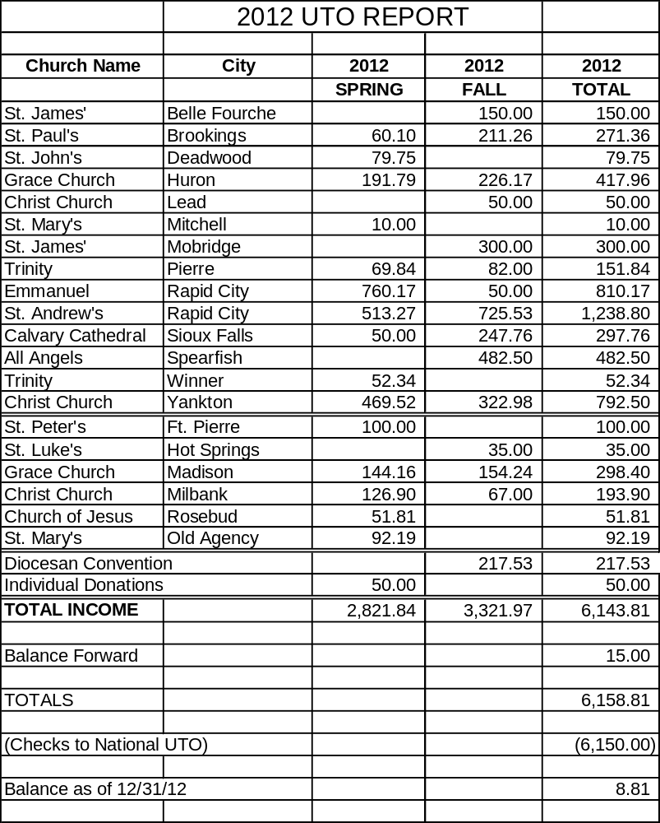

FINANCIAL REPORTS

FINANCIAL REPORTS

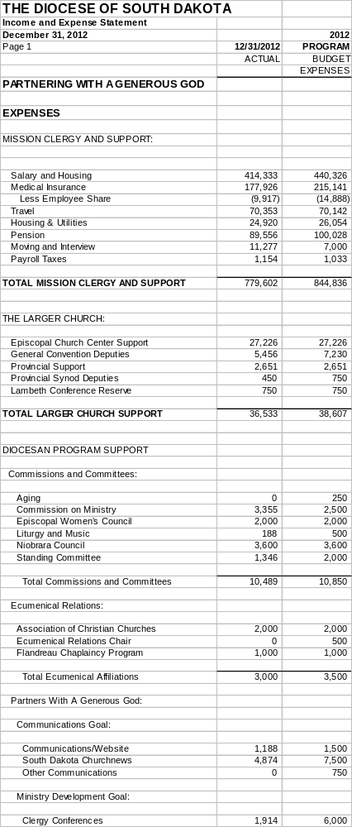

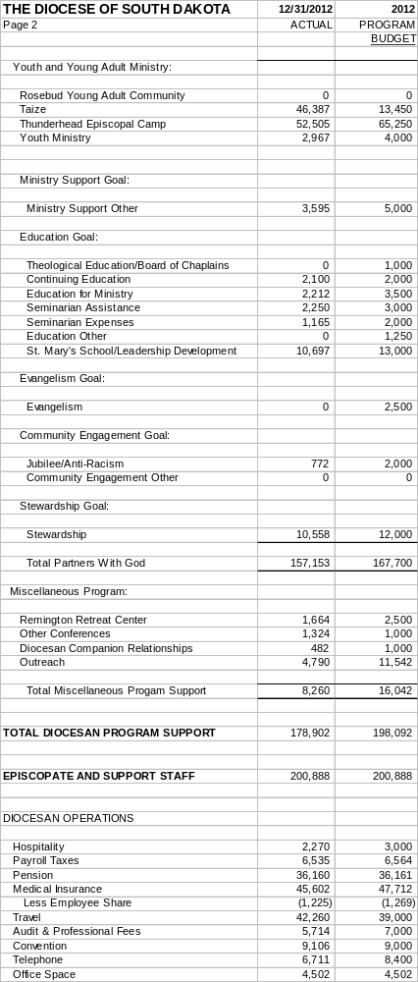

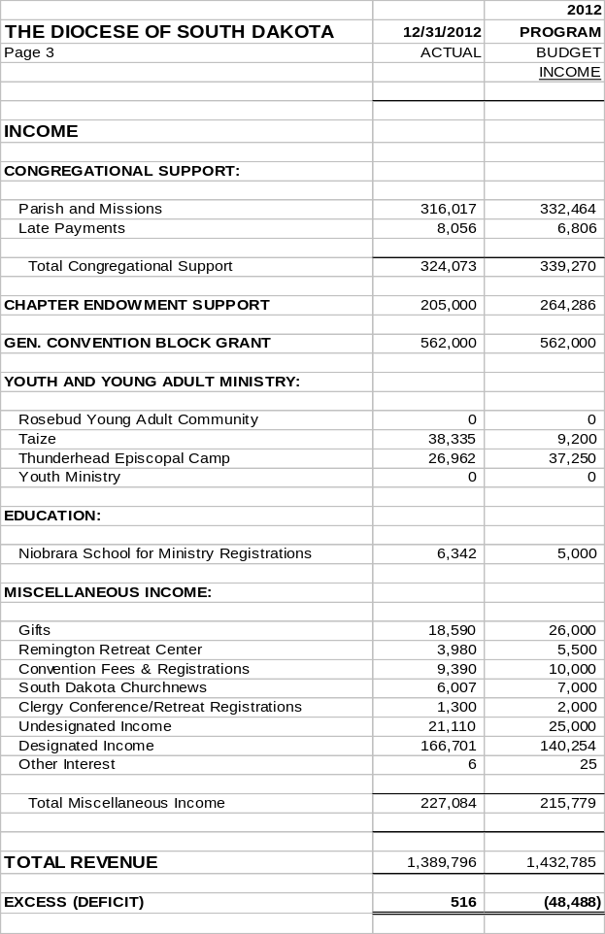

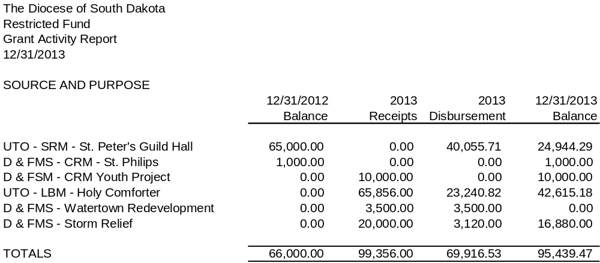

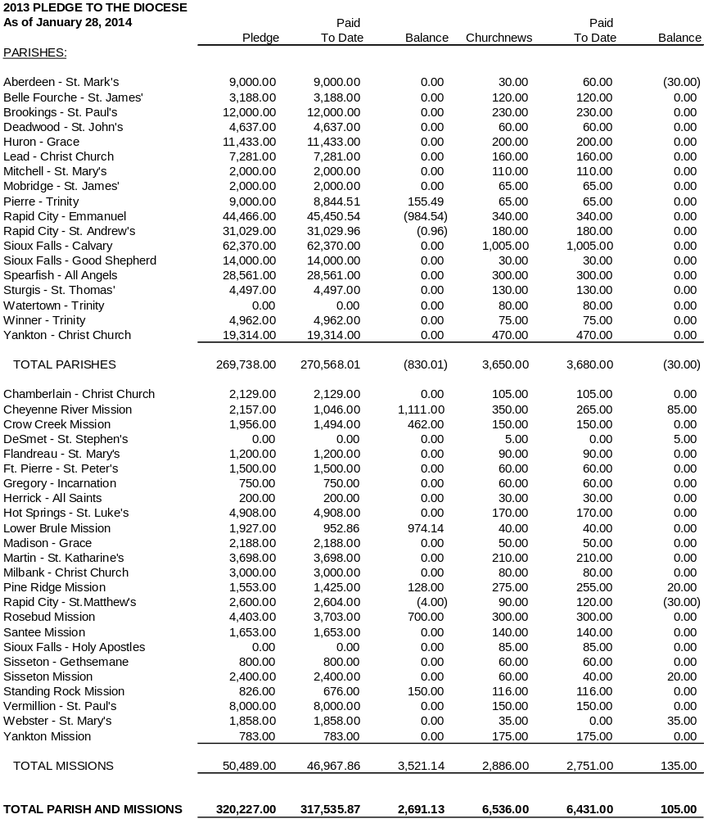

STATISTICAL REPORTS

